Significant World Events Over the Past 1000 Years

1215- Magna Carta or Magna Charta [Lat., = great charter], the most famous document of British constitutional history, issued by King John at Runnymede under compulsion from the barons and the church in June, 1215.
Since the time of Edward the Confessor in the 1000s AD, the kings of England had been getting more and more powerful. That was pretty much okay as long as the kings were good kings, like William the Conqueror or Henry II. But when King Richard died in 1199, his younger brother John became king, and John was not such a good king.
King John didn't seem to be taking such good care of England. First he lost almost all of the English land in France. Then he made everyone who owned land in England pay extra taxes. And he got into fights with the Pope about who would control the Catholic Church in England. King John's fight with the Pope got so bad that the Pope excommunicated him (and then they made up).
So in 1215 AD the rich men of England - the earls, the dukes, and the counts - decided to try to get back some of the power from the king. They wrote a letter (Latin "carta") saying that everyone in England would have certain rights, that the king could not take away from them anymore. The Magna Carta insisted that even the king had to obey the law. This was not a new idea - Roman emperors were supposed to obey the law, and early medieval kings were elected by the rich men of their kingdom and could be removed if they behaved badly. But the kings were always trying to get more power, so the rich men needed to push back in order to keep their rights.
Most of the rules that the rich men wrote down in the Magna Carta aren't laws anymore today. The most important rule that we do still use today is habeas corpus, which means "Do you have the body?" in Latin. This rule means that the government can't keep people in jail secretly. The government has to tell the public if someone has been arrested or is being held for any reason. Habeas corpus protects people from being kidnapped by the government for no reason, or for bad reasons.
http://www.historyforkids.org/learn/medieval/government/magnacarta.htm#!
https://www.youtube.com/watch?v=xVCDmyeZLas Magna Carta Informational Video
https://www.youtube.com/watch?v=4qj2vpp9Wf4 Magna Carta Comic-Strip-type video
1271- Marco Polo was one of the first and most famous Europeans to travel to Asia during the Middle Ages. He traveled farther than any of his predecessors during his 24-year journey along the Silk Road, reaching China and Mongolia, where he became a confidant of Kublai Khan.
Marco Polo was only 15 years old when he left Venice on the great adventure that took him to the court of Kublai Khan. His father Niccolò and his uncle Maffeo Polo had made the journey previously. Marco barely knew his father, who had spent Marco's childhood as a traveling merchant when they left on their quest. But the death of Marco's mother convinced Niccolò that Marco should accompany him on the return trip, which lasted 24 years (1271-1295). The Polos weren't the first wayfarers — Marco's word — to make it to Asia, but Marco is the one who became most famous for it.
No. 2: Marco Polo did not bring pasta back to Venice from China. It is one of the most famous legends out there about the adventurer, but truth be told, pasta had made its way into the cuisine of Italy prior to Marco's birth. He did, however, introduce the concept of paper money, which was used in Mongolia in the 13th century, but not in Europe.
No. 3: The Travels of Marco Polo [the English title] was not written by Marco, but rather by the 13th-century romantic author Rustichello of Pisa. The two met while in prison, where Marco dictated the stories of his travels and his adventures at the court of Kublai Khan. [Marco was a prisoner of war, having been captured in a battle between Venice and its rival city-state Genoa in 1298.] There are no longer any original copies remaining of the manuscript, initially titled Il Milione (The Million) and released in Italian, French and Latin. The earliest remaining copies of the travelogue are not always consistent in details, but do remain true to the stories. Keep in mind the printing press wasn't invented until 1439, so the books were handwritten and mistakes were made. http://www.biography.com/news/marco-polo-facts-netflix-series
No. 4: While Marco Polo didn't actually discover America, he was influential in Christopher Columbus's decision to strike out for unknown territory. Columbus is said to have been inspired by Marco's adventures, and took a copy of The Travels of Marco Polo on his Westward sail two centuries after Marco's journey to China.
No. 5: Many of us have spent a summer's afternoon in a swimming pool playing the tag game of Marco Polo, but did you know that the Venetian merchant also has a species of sheep named after him? In The Travels of Marco Polo, he mentions observing the mountain sheep on the Pamir Plateau in Badakhshan [now northeastern Afghanistan]. Of course, the sheep weren't named after him in his lifetime. The first scientific mention of Ovis ammon polii was in 1841 by zoologist Edward Blyth.
No. 6: In addition to his native tongue, Marco wrote that he knew four languages. He never elaborated on which four they were, but from his writings, historians have surmised they were Mongolian, Persian, Arabic, and Turkish — not Chinese.
No. 7: Marco served as a special envoy for the great Kublai Khan, providing the leader with useful reports from the various trips he took on his behalf all around Asia. This included three years during which he served as the governor of the city of Yangchow.
No. 8: The Polos finally grew homesick, but Kublai Khan valued their services so much, he refused to let them go. They were finally able to return home when they convinced him that they should be the escorts for Princess Kokachin, who was to marry his great nephew, the Il-Khan, who ruled Persia. The journey to Persia was a perilous one, and many died, but the Polos arrived safely. Kublai Khan, too, died while they were on this mission, so they were able to return to Venice following the wedding.
https://www.youtube.com/watch?v=htUiZ4b5Qq8 Marco Polo
https://www.youtube.com/watch?v=LMk-bqfjNQI Marco Polo Movie
1300s- Italian Renaissance
The renaissance (or rebirth) is an Italian idea, and the Italian Renaissance generally covers the periods from the beginning of the fourteenth century to the end of the sixteenth century.
The renaissance marked a great cultural change throughout the whole of Europe and is viewed as a bridge between the medieval and modern ages. Scholars schooled in literature along with poets, courtiers and schoolmasters, all with a powerful thirst for learning, became known as the intellectual movement the humanists. They rediscovered Greek and Latin texts and began to teach Latin literature. The poet, historian and philosopher, Francesco Petrarch (1304-1374) was one of the leading lights of the movement.
It was this explosion of free thinking that eventually spread to the artists and architects of the fifteenth century. The independent cities of central and northern Italy with their politically and economically successful institutions such as banking, workshops and universities provided ideal conditions for the emergence of Humanism.
Beginning in Italy the new thinking eventually spread to the rest of Europe.
The fourteenth century, or Trecento, artists shed the mosaics associated with the Byzantine period and took inspiration from classical Greek and Roman sculptors.

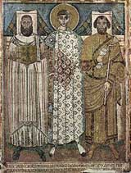
Typical Byzantine Mosaic
8th century.(w)
The Italians of the period considered themselves to be living in a golden age, superior to anything since the fall of the roman empire a thousand years earlier, with painting, sculpture, music, poetry and architecture all awakening to a revival after sleeping for centuries.
The Renaissance had a profound influence on the course of the development of modern American society, culture, and, since it is a natural extension of both, artistic expression. The Renaissance influence in America brought about a new focus on humanism and as a result, a subsequent turning away from the dominant ideals put forth by the church. Although religion was still of the greatest influence throughout the period of the Renaissance, the dawning recognition of human potential and scientific inquiry shaped the course of Western history and does still influence contemporary American culture today. Principles of realism, particularly as they appeared in terms of art and literature have remained vital in all aspects of American society and figures such as Boccaccio, da Vinci, Machiavelli, and others live on and influence the way we view our world today.
http://www.articlemyriad.com/influence-renaissance-modern-american-society/
https://www.youtube.com/watch?v=zB-nfp-JxHQ Italian Renaissance Video
https://www.youtube.com/watch?v=Vufba_ZcoR0 Crash Course Italian Renaissance

1347-Bubonic Plague

Introduction
plague, any contagious, malignant, epidemic disease, in particular the bubonic plague and the black plague (or Black Death), both forms of the same infection. These acute febrile diseases are caused by Yersinia pestis ( Pasteurella pestis ), discovered independently by Shibasaburo Kitasato and Alexandre Yersin in 1894, a bacterium that is transmitted to people by fleas from rats, in which epidemic waves of infection always precede great epidemics in human populations. Sylvatic plague, still another form, is carried by other rodents, e.g., squirrels, rabbits, chipmunks, in rural or wooded areas where they are prevalent.
Bubonic plague, the most common form, is characterized by very high fever, chills, prostration, delirium, hemorrhaging of the small capillaries under the skin, and enlarged, painful lymph nodes (buboes), which suppurate and may discharge. Invasion of the lungs by the organism (pneumonic plague) may occur as a complication of the bubonic form or as a primary infection. Pneumonic plague is rapidly fatal and is the only type that can be spread from person to person (by droplet spray) without intermediary transmission by flea. In the black form of plague, hemorrhages turn black, giving the term "Black Death" to the disease. An overwhelming infection of the blood may cause death in three or four days, even before other symptoms appear.
In untreated cases of bubonic plague the mortality rate is approximately 50%–60%; pneumonic plague is usually fatal if not treated within 24 hours. Such antibiotics as streptomycin and tetracycline greatly reduce the mortality rate. Vaccine is available for preventive purposes. Rodent control is important in areas of known infection. http://www.factmonster.com/encyclopedia/science/plague.html

The Black Death was one of the worst pandemics in human history. In the 14th century, at least 75 million people on three continents perished due to the painful, highly contagious disease. Originating from fleas on rodents in China, the “Great Pestilence” spread westward and spared few regions. In Europe’s cities, hundreds died daily and their bodies were usually thrown into mass graves. The plague devastated towns, rural communities, families, and religious institutions. Following centuries of a rise in population, the world’s population experienced a catastrophic reduction and would not be replenished for more than one hundred years. Origins and Path of the Black Death
The Black Death originated in China or Central Asia and was spread to Europe by fleas and rats that resided on ships and along the Silk Road. The Black Death killed millions in China, India, Persia (Iran), the Middle East, the Caucasus, and North Africa. To harm the citizens during a siege in 1346, Mongol armies may have thrown infected corpses over the city wall of Caffa, on the Crimean peninsula of the Black Sea. Italian traders from Genoa were also infected and returned home in 1347, introducing the Black Death into Europe. From Italy, the disease spread to France, Spain, Portugal, England, Germany, Russia, and Scandinavia.

Science of the Black Death
The three plagues associated with the Black Death are now known to be caused by bacteria called Yersinia Pestis, which is carried and spread by fleas on rats. When the rat died after continual bites and replication of the bacteria, the flea survived and moved to other animals or humans. Although some scientists believe that the Black Death was caused by other diseases like anthrax or the Ebola virus, recent research which extracted DNA from the skeletons of victims suggests that Yersinia Pestis was the microscopic culprit of this global pandemic.

Types and Symptoms of the Plague
The first half of the 14th century was marred by war and famine. Global temperatures dropped slightly, decreasing agricultural production and causing food shortages, hunger, malnutrition, and weakened immune systems. The human body became very vulnerable to the Black Death, which was caused by three forms of the plague. Bubonic plague, caused by flea bites, was the most common form. The infected would suffer from fever, headaches, nausea, and vomiting. Swelling called buboes and dark rashes appeared on the groin, legs, armpits, and neck. The pneumonic plague, which affected the lungs, spread through the air by coughs and sneezes. The most severe form of the plague was the septicemic plague. The bacteria entered the bloodstream and killed every person affected within hours. All three forms of the plague spread quickly due to overpopulated, unsanitary cities. Proper treatment was unknown, so most people died within a week after infection with the Black Death.

Death Toll Estimates of the Black Death
Due to poor or non-existent record-keeping, it has been difficult for historians and scientists to determine the true number of people that died of the Black Death. In Europe alone, it is likely that from 1347-1352, the plague killed at least twenty million people, or one-third of Europe’s population. The populations of Paris, London, Florence, and other great European cities were shattered. It would take approximately 150 years-into the 1500s- for Europe’s population to equal pre-plague levels. Initial plague infections and recurrences of the plague caused the world’s population to drop by at least 75 million people in the 14th century.

Unexpected Economic Benefit of the Black Death
The Black Death finally lapsed in approximately 1350, and profound economic changes took place. Worldwide trade declined, and wars in Europe paused during the Black Death. People had abandoned farms and villages during the plague. Serfs were no longer tied to their previous plot of land. Due to a severe labor shortage, serf survivors were able to demand higher wages and better working conditions from their new landlords. This may have contributed to the rise of capitalism. Many serfs moved to cities and contributed to the rise in urbanization and industrialization.

Scourge Spread Across the World
The Black Death of the 14th century was a tremendous interrupter of worldwide population growth. The bubonic plague still exists, although it can now be treated with antibiotics. Fleas and their unknowing human carriers traveled across a hemisphere and infected one person after another. Survivors of this swift menace seized the opportunities that arose from altered social and economic structures. Although humanity will never know the exact death toll, researchers will continue to study the epidemiology and history of the plague to ensure that this horror never happens again. http://geography.about.com/od/culturalgeography/a/Impacts-Of-The-Black-Death.htm
https://www.youtube.com/watch?v=ldZjaT4WXrA Black Plague Video
https://www.youtube.com/watch?v=ySClB6-OH-Q Ted Talks Black Death Video
1438—Incan Empire formed in Peru
The Inca Empire was a complex society with an estimated population of 10 million people. They had large stone cities, beautiful temples, an advanced government, a detailed tax system, and an intricate road system.
The Inca, however, didn't have a lot of basic technologies we often consider important to advanced societies. They didn't use the wheel for transport, they didn't have a writing system for records, and they didn't even have iron for making tools. How did they create such an advanced Empire?
Below are some of the important scientific innovations and technologies used by the Inca Empire.
Roads and Communication
The Incas built a large system of roads that went throughout their empire. The roads were usually paved with stone. Stone steps were often built into steep areas in the mountains. They also built bridges where the roads needed to cross rivers.
The remains of an Ancient Inca road
The main purpose for the roads was for communication, moving army troops, and to transport goods. Commoners were not allowed to travel on the roads.
Communication was accomplished by runners on the roads. Fast young men called "chaskis" would run from one relay station to the next. At each station they would pass the message on to the next runner. Messages were either passed verbally or by using a quipu (see below). Messages traveled quickly this way at the rate of around 250 miles per day.
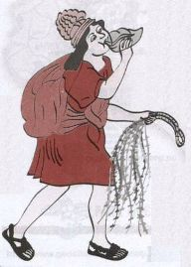
An Inca Chaski runner
Quipus
A quipu was a series of strings with knots. The number of knots, the size of the knots, and the distance between knots conveyed meaning to the Inca, sort of like writing. Only specially trained officials knew how to use quipus.

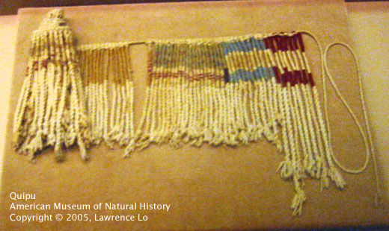
A drawing of a quipu

Stone Buildings

The Inca were able to create sturdy stone buildings. Without the use of iron tools they were able to shape large stones and have them fit together without the use of mortar. By fitting the stones closely as well as other architectural techniques, the Inca were able to create large stone buildings that survived for hundreds of years despite the many earthquakes that occur in Peru.

Farming

The Inca were expert farmers. They used irrigation and water storage techniques to grow crops in all sorts of terrain from the deserts to the high mountains. Despite not having beasts of burden or iron tools, the Inca farmers were very efficient.

Calendar and Astronomy

The Inca used their calendar to mark religious festivals as well as the seasons so they could plant their crops at the correct time of the year. They studied the sun and the stars to calculate their calendar.

The Inca calendar was made up of 12 months. Each month had three weeks of ten days each. When the calendar and the sun got off track, the Inca would add a day or two to bring them back into alignment.

Government and Taxes

The Inca had a complex system of government and taxes. Numerous officials kept watch over the people and made sure that the taxes were paid. The people were required to work hard, but their basic needs were provided.

Interesting Facts about Inca Science and Technology •The messengers who ran on the roads were punished harshly if the message was not accurately delivered. This rarely happened.
•The Inca built a variety of bridges including suspension bridges and pontoon bridges.
•One of the main forms of medicine used by the Inca was the coca leaf.
•The Inca developed aqueducts to bring fresh water into town.
•The basic unit of distance used by the Inca was one pace or a "thatki".
http://www.ducksters.com/history/inca/science_and_technology.php
https://www.youtube.com/watch?v=3F7G0VeqAeY&list=PL9SLkANZIEtW1RXLPhORY_-HlB3qro0vt Video Clip

1760—Industrial Revolution begins in England

Why did the Industrial Revolution Start in England?
By the end of the 19th century, the island of Great Britain, which is about the size of the state of Louisiana, controlled the largest empire in the history of the world—an empire that covered one quarter of the world’s land mass. You will learn more about this empire in the next chapter. But how did this little island come to rule an empire? How did Great Britain acquire so much military and economic power in the world? The answer, of course, is that it had an enormous commercial and technological head start over the rest of the world because the Industrial Revolution started in England. But why did the Industrial Revolution occur first in England and not somewhere else in the world? Historians describe a confluence—a coming together—of many factors and they do not agree on which are most important. Some of these factors we discussed earlier because they had their seeds in pre-industrial society. All of these factors came together in the late 18th century to create the unique conditions in England that culminated in the first-ever Industrial Revolution:
The Agricultural Revolution discussed earlier resulted in increased food production and increased population in England first.
Population Growth, also discussed earlier, resulted in more people from the countryside being freed up to work for wages in the new cities,— and eventually increased demand for products such as clothing.
Financial Innovations—such as central banks, stock markets, and joint stock companies—encouraged people, especially in Northern Europe, to take risks with investments, trade, and new technologies.
The Enlightenment and the Scientific Revolution encouraged scholars and craftspeople to apply new scientific thinking to mechanical and technological challenges. In the centuries before the Industrial Revolution, Europeans gradually incorporated science and reason into their worldview. Some historians argue that these intellectual shifts made English culture, in particular, highly receptive to new mechanical and financial ideas.
Navigable Rivers and Canals in Great Britain quickened the pace and cheapened the cost of transportation of raw materials and finished products. Adam Smith, the first modern economist, believed this was a key reason for England’s early success. In 1776, in his famous book An Inquiry into the Nature and Causes of the Wealth of Nations, he wrote that “Good roads, canals, and navigable rivers, by diminishing the expense of carriage, put the remote parts of the country more nearly upon a level with those in the neighbourhood of the town. They are upon that account the greatest of all improvements” (Weightman 43).
Coal and Iron deposits were plentiful in Great Britain and proved essential to the development of all new machines made of iron or steel and powered by coal—such as the steam-powered machinery in textile factories, and the locomotive.
Government Policies in England toward property and commerce encouraged innovation and the spread of global trade. The government created patent laws that allowed inventors to benefit financially from the “intellectual property” of their inventions. The British government also encouraged global trade by expanding the Navy to protect trade and granting monopolies or other financial incentives to companies so they would explore the world to find resources.
World Trade gradually increased in the centuries before the Industrial Revolution and provided European countries access to raw materials and a market for goods. It also increased wealth that could then be loaned by banks to finance more industrial expansion in an upward spiral of economic growth. By 1500, Europe had a technological supremacy over the rest of the world in shipbuilding, navigation, and metallurgy (metal working). In successive years, European countries would use these advantages to dominate world trade with Asia, Africa, and the Americas.
The Cottage Industry, discussed earlier, served as a transition from a rural to an industrial economy. Like the later industrial factories, the cottage industry relied on wage labor, cloth production, tools and rudimentary machines, and a market to buy and sell raw materials (cotton) and finished products (clothes).

The Big Industrial Innovations: How the Industrial Revolution Began in Great Britain
We have learned many reasons why industrialization started in Europe and England. But which industry triggered the Industrial Revolution in England? Well, it all started with the textile (cloth) industry. Making cloth, by hand, for pants, shirts, socks, bedspreads and other domestic items had always required lots of skill and time. As population grew in England, more people needed and were willing to buy textile goods. The cottage industry showed how much people could produce in their homes through spinning and weaving cloth by hand. But this domestic production system could not keep up with the growing demands of England’s growing population. Instead, starting in the late 18th century, a series of innovations shifted textile production to a new factory system. And cotton led the way. As a result of the Industrial Revolution, cotton became the world’s most important non-food agricultural product-- and it remains so to this day.
In the 1700s, cotton textiles had many production advantages over other types of cloth. The first textile factory in Great Britain was actually for making silk. But, since only wealthy people could afford the product, production remained very low. Cotton, on the other hand, was far less expensive. It was also stronger and more easily colored and washed than wool or linen.
One challenge of using cotton, however, was that the British did not grow any cotton plants because of their cold climate. So, they revved up trade with cotton producers far across the world, such as India and the Southern United States. Look at the table below of American cotton production during the first stage of the Industrial Revolution. Almost all of this raw cotton, processed by slave labor, was sold to England. This cotton production soared as new inventions made textile production increasingly inexpensive and efficient.
American Production of Raw Cotton, 1790-1860 (in bales)
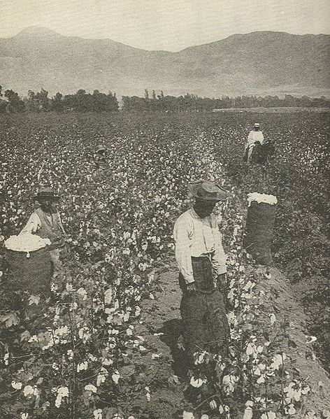  Year | Production
1790 | 3, 135
1795 | 16,719
1800 | 73,145
1805 | 146,290
1810 | 177,638
1815 | 208,986
1820 | 334,378
1825 | 532, 915
1830 | 731,452
1835 | 1,060,711
1840 | 1,346,232
1845 | 1,804,223
1850 | 2,133,851
1855 | 3,217,417
1860 | 3,837,402
(Gray)

Textile Inventions
In 1733, James Kay, a clockmaker, invented a simple weaving machine called the flying shuttle. He built it, supposedly, with nothing more than a pocketknife as his tool. The flying shuttle improved on the old hand loom. A worker pulled a cord of rope back and forth to send a small piece of canoe-shaped wood, or shuttle, “flying” across a wood frame through threads to weave cloth. The machine only came into general use in the 1760s—after decades of trial-and-error improvements—but once adopted, this first big invention in the textile industry doubled worker productivity: one adult weaver could accomplish the work of two. The invention was a small improvement and was still powered by people rather than coal, wind, or water. Nonetheless it began the crucial process by which unskilled workers could produce more cloth with machines than skilled workers could produce by hand (Weightman 55).
http://webs.bcp.org/sites/vcleary/ModernWorldHistoryTextbook/IndustrialRevolution/videohandshuttle.html
https://www.youtube.com/watch?v=khiEAEqdkZY&feature=youtu.be Fly Shuttle Weave
In the 1760s, spinning innovations finally caught up with the weaving capacity of the flying shuttle. The hardest part was to create a subtle mechanized device for pulling and twisting the cotton fiber just the right amount to create strong thread. In 1764, James Hargreaves invented such a device, called a spinning jenny— “jenny” or “jen” was short for “engine.” So, think of it as a “spinning engine.” With eight spindles, the spinning machine immediately increased by eightfold the amount a worker could produce. The spinning jenny could fit into a small cottage and be operated by unskilled workers, including children. But some were not pleased with the innovation. Workers skilled at the old spinning wheel, and fearful that the new machine would take their jobs, marched over to Hargreaves’ house and destroyed twenty of the first new machines before they could be used. Worse still for Hargreaves, his patent claim on one of the most famous inventions of the Industrial Revolution was invalidated because he applied for it after he had already sold several machines (Rosen 222-224).
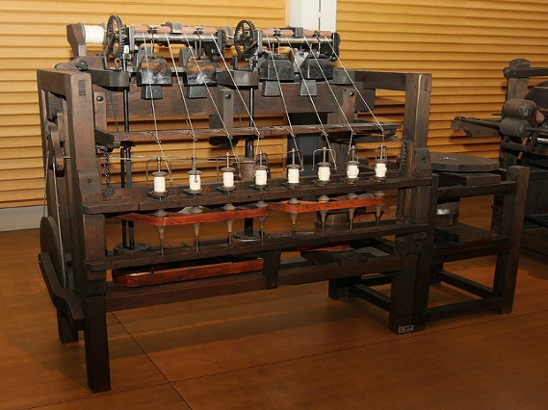
The next big challenge for the industrial tinkerers was to engineer a way that these new machines could be powered by an energy source that was more efficient and powerful than human muscle. In 1769, Richard Arkwright, a barber and wigmaker, figured out how to hook up a new spinning machine to a water wheel. It is possible that John Kay, a clockmaker that Arkwright met in a pub, might have had the original idea, but Arkwright made use of it and called it the water frame. Arkwright’s spinning factory opened in 1771 along the River Derwent. It was an immediate success, spinning strong, high-quality threads cheaply and better than those spun by hand or a spinning jenny. Arkwright’s cotton factory spun 24 hours a day, employing mostly women and children on 12-hour shifts. Each water frame spun 91 spools at a time, more than almost 100 people could spin on an old spinning wheel. Arkwright’s business took off in large part due to the assistance of the British Parliament, which, to protect the new English textile industry, outlawed the importation of superior cotton cloth from India (Ashton, 57-58).
Another inventor, Samuel Crompton, combined the spinning and weaving process into one machine in 1774. Raw cotton could be introduced in one end and produce cloth on the other. Crompton failed to patent his invention, but the enterprising Arkwright immediately incorporated it into his new factories. The invention was called a spinning “mule” because, like a mule, it was the offspring of two different types of parents. With Crompton’s mule, Arkwright now had the most productive textile mills in the world. Arkwright guarded his patents and charged extremely high royalties to use them. As a result, he dominated the early spinning industry and became fabulously wealthy. Ten years after giving up wigmaking and taking a risk to start his own factory, he employed 5,000 workers, including children as young as six (Rosen 228-233).
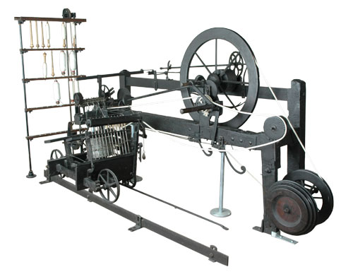
Arkwright was not a great inventor. He borrowed most of his ideas from others. But he was one of the first and most successful entrepreneurs of the early Industrial Revolution; he understood the potential of these new textile inventions to produce inexpensive and high quality cloth. When others complained in court that he had stolen their ideas, Arkwright responded that “if any man has found a thing, and begun a thing, and does not go forwards. . . another man has a right to take it up and get a patent for it” (233). He, perhaps more than any other single person, created the cotton industry that spurred the Industrial Revolution and created great wealth for himself and for England. From 1800 to 1850, cotton products accounted for the majority of monetary value for British exports (Stearns 29).
In 1785, Edmund Cartwright invented the power loom, another game changer. Although it did not become widely used until after 1800, it was powered by steam and thus replaced the flying shuttle, which could not compete with the new loom’s weaving speed and efficiency. Cartwright explained his inspiration:
As soon as Arkwright’s patent [for spinning] expired, so many mills would be erected and so much cotton spun that hands would never be found to weave it. . . . It struck me that as plain weaving can only be three movements which were to follow each other in succession, there would be little difficulty in producing them and repeating them. Full of these ideas I immediately employed a carpenter and smith to carry them into effect. As soon as the machine was finished, I got a weaver to put in a warp, which was of such materials as sailcloths are usually made of. To my great delight, a piece of cloth, such as it was, was the product.
http://webs.bcp.org/sites/vcleary/ModernWorldHistoryTextbook/IndustrialRevolution/videopowerloom.html Power Loom in Action!
Cartwright’s invention took many years to refine because it was difficult for the loom to weave quickly and mechanically without the thread slackening or the shuttle moving too slowly or too rapidly. The first power looms were installed in a factory in Manchester, where they suffered a similar fate to the first spinning jennies. Some Manchester craft weavers, worried that they would lose their skilled jobs, threatened the first power loom factory and soon afterwards a fire mysteriously destroyed it (239). But the genie was out of the bottle—no other loom could compete. Like the spinning mule, the power loom and the steam engine that powered it could not fit into a cottage. All these big, heavy machines would need to be brought under one large roof. The cottage industry had died, but factories were just beginning to house industry. And these larger machines and factories led to enormous growth in other industries, especially those of coal and iron.

The Iron Industry
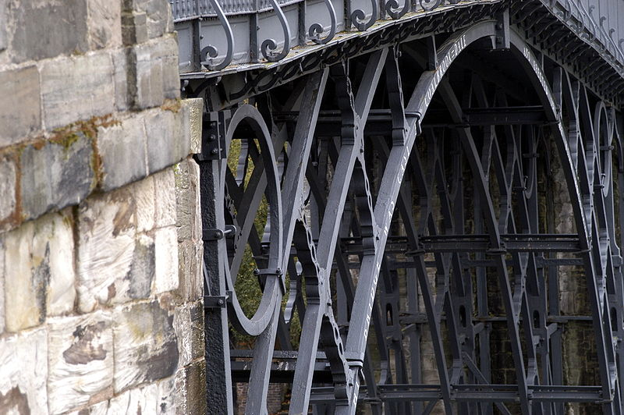
In the centuries before the Industrial Revolution, the quality of iron and the process of refining it had changed little in Great Britain. Iron had been used for agricultural tools, chains, locks, bolts, nails, horse stirrups, scythes, sickles, and anchors. Through a laborious and very time-consuming process, master ironcrafters could even make steel, a form of processed iron, with fewer impurities, reserved for making knives, razors, swords, guns and small working parts for clocks and watches. In the 18th century, ironmongers began to experiment with ways to tease out more impurities from iron. They wanted to make their iron stronger and less expensive, and they also wanted to make the tedious process of iron-making more efficient (Weightman 28-33).
Henry Cort, an ironmaster pursuing a way to refine iron,discovered two methods that changed the industry. He reheated bars of iron, melting them down to apaste, mixed the paste and heated it with coke (a substance burned off from coal), then stirred it so that carbon and many impurities burned off. The purified iron was rolled up into a puddled ball and finally rolled out to squeeze out any dross that remained. Cort called the process “puddling and rolling” and patented it in 1785. This iron-refining process allowed England to stop importing iron from northern Europe and instead to grow the largest iron industry in the world. This cheaper and stronger iron galvanized every major industry—construction, tools, shipbuilding, textile inventions, steam engines and railroads (54-55). Unfortunately, Cort later lost all the wealth he created for himself, including his patents, when it was discovered that he had embezzled money from the British Navy to buy his first iron forgery. (Rosen 56) Nevertheless, iron production in Great Britain skyrocketed.
Amount of Iron Produced in Great Britain
Periods | Metric Tons of Pig Iron
1781-1790 | 69,000
1825-1829 | 669,000
1855-1859 | 3,583,000
1875-1879 | 6,484,000
1900-1904 | 8,778,000
(Cipollal Fontana Economic History of Europe)

The Steam Engine
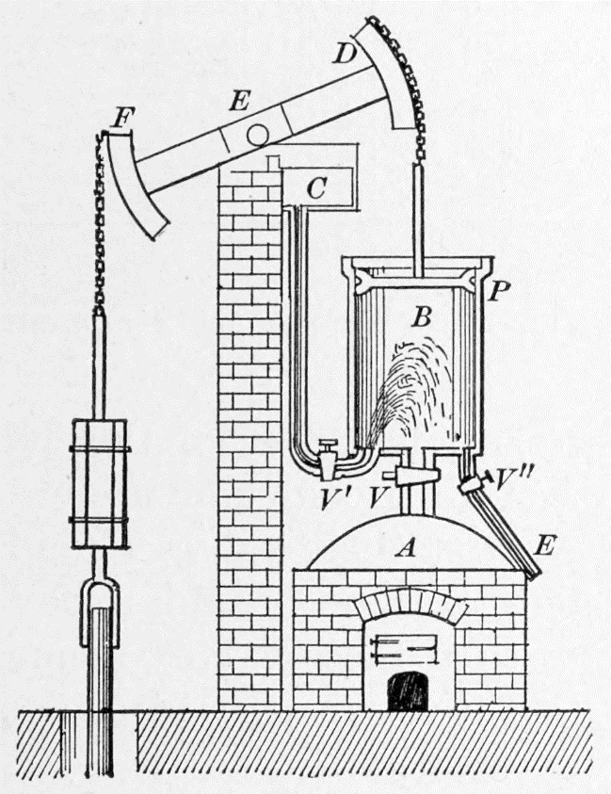
The defining invention of the Industrial Revolution was most definitely the steam engine. The steam engine was the energy behind the most advanced textile inventions, such as the spinning mule and the power loom. It symbolized the transition from human power in homes to machine power in factories. Moreover, the steam engine revolutionized transportation when it was applied to locomotives and ships. So how did this amazing invention come about? And how did it work?
The steam engine was originally invented in England to pull water out of coal mines. For thousands of years, wood from local forests had been the main fuel in England, as well as the main material for shipbuilding and housing construction. By the end of the 17th century, however, few forests remained (Weightman 28-33). So the English sought to find an alternative energy source for heating. They turned to coal, which was in great supply. By the early 1700s, the easy-to-reach open coal pits were gone, and mine shafts as deep as 200 feet were dug to find it (27). In these deep shafts, groundwater would eventually seep in and flood the tunnels. This seepage was dangerous for miners and expensive for mine owners. Miners used pots, hand pumps and, occasionally, windmills to drain the water. Finally, in 1708, Thomas Newcomen invented a simple engine that used steam to pump water out of coalmines. Here’s how his engine worked. Boiled water created steam, which entered a chamber or cylinder, which pushed a piston up. The piston lifted a pump. Watch this animation to see it in action. Newcomen’s steam engine worked—slowly. But it could only create a pumping motion and not a rotating motion that might be used to grind wheat or move machinery. In fact, it was so inefficient in its use of energy that nobody used it for any other purpose for over sixty years (30).
In the 1760s, James Watt (1736-1819), a Scottish instrument maker, teamed up with professors from the University of Glasgow to improve Newcomen’s engine. In the old engine, as you can see from the animation, a piston moved up and down as steam was injected: this steam pushed the piston up the cylinder, then condensed on the down stroke (see animation here). The piston cylinder in Newcomen’s engine had to alternate between hot and cold temperatures, to expand or condense the steam—warm on the upstroke and cold on the downstroke. But this resulted in a waste of energy and a waste of time, as the piston cylinder changed temperature and had to be constantly reheated. The burning question: how could the piston cylinder remain hot and cool at the same time? (35-36)
In 1765, the twenty-nine-year-old Watt, strolling across the town square in Glasgow and reflecting on the inefficiency of Newcomen’s engine, had a flash of insight, an epiphany. “The whole thing was arranged in my mind,” he said. He suddenly understood that a separate cylinder—called a condenser—could be kept permanently cool while being connected to the piston cylinder, which would remain hot (35-36). Watt recalled, “The idea came into my mind, that as steam was an elastic body it would rush into a vacuum, and if a communication were made between the cylinder and an exhausted vessel it would rush into it, and might be there condensed without cooling the cylinder” (Rosen 115).
Putting the insight into practice, Watt added a second cylinder or chamber. The steam would be sucked out of the piston chamber and into the new cylinder, cool off, condense, and thus form a vacuum that used atmospheric pressure to move the piston. Meanwhile, the cylinder with the moving piston remained hot as another injection of steam entered. (104 see photo on page 105) Watt patented the idea of this separate condenser in 1769. Known for this famous flash of insight, Watt was actually a relentless and careful experimenter, a student of the Scientific Revolution. In all his work, he used rigorous and precise scientific methods to test his ideas.
After years of struggling on his own to make the new steam engine work correctly, Watt successfully teamed up with the largest and most famous factory in the world, Soho Manufactory, which made jewelry, silverware, and tools in Birmingham, England. The owner was looking for an energy source that was more powerful than water wheels. At Soho, Watt met and collaborated with the most skilled ironworkers and engineers in the country. With their help, the new engine became four times as productive as Newcomen’s. Watt continued to tinker and improve it so that steam could be injected into both sides of the piston cylinder, creating a double-acting piston. In 1781, Watt pressed on further to adapt the engine from a reciprocal up-and-down motion to a turning or rotary motion. Now, the steam engine could supply consistent and cheap energy for all the latest textile inventions. At the insistence of one of his engineers, Watt patented a steam-powered carriage but didn’t think much would come of it. (Weightman 58-9)
Watt’s rotary steam engine was being perfected just at the same moment that iron-working improved and textile inventions were becoming more powerful, greater in size, sizeable and in need of better, cheaper, and more reliable power sources. The new steam engine could be harnessed to all these new inventions. In 1782, the year after Watt perfected the rotary steam engine, there were only two cotton mill factories in Manchester. Twenty years later there were more than 50. (Ashton 60)

The Factory
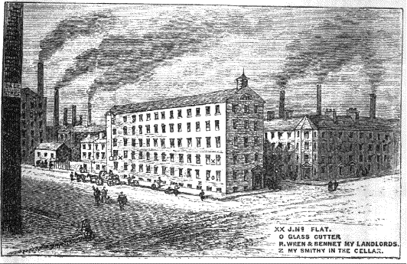
The idea for the first textile factory—a word derived from “manufactory,” the place where goods were manufactured—came from a British silk mill worker, John Lombe. He travelled to Northern Italy to steal designs for secret Italian machines that spun and wove the silk (it is worth noting here that the Chinese had been spinning and weaving silk with simple looms for thousands of years before the Italians.) In 1719, Lombe patented the ideas as his own in Great Britain and built a large building next to a river to use a water wheel to power the machines. The mill was five stories high and employed 200 men. Silk was a luxury item that most could not afford, and so few enterpeneurs followed in Lombe’s footsteps. But this silk factory came into mind years later when industrialists were looking for ways to power new textile inventions at one location. As textile inventions grew in size , they could no longer fit in cottages (Rosen 212-217; wikipedia article on factories).
Like Lombe’s old silk factory, the first textile factories were located on rivers so that a water wheel could provide a reliable and consistent rotating power for the new inventions. Arkwright built his first cotton mill just away from a river and dug out a channel or millrace, so that the water wheel benefitted from the current, as well as the gravity of water coming down hill and into a narrow chute (Rosen 230).
But, the invention of Watt’s rotary steam engine changed everything. Textile factories no longer had to be built right next to a river. However large buildings were required for the new large steam engines, spinning mules, and power looms. In 1790, Arkwright used steam power to run his spinning mule factory. Workers, along with their families, congregated at these new factories. Their need for stores, churches and the like resulted in the formation of small communities, which became towns and cities.
Another important result of the factory was specialization of labor. In 1776, Adam Smith, a Scottish economist, wrote the all-time most influential and famous economics book: Wealth of Nations. For Smith, the key to the efficiency, productivity, and quality control of a factory was the division of labor. This was a process by which the key tasks in manufacturing were identified and assigned to individual workers to specialize, perfect and repeat with dispatch. *********Add sentence about effects/relevance of this approach or at least how “revolutionary”/different it was from before or how it fueled growth.

Railroads
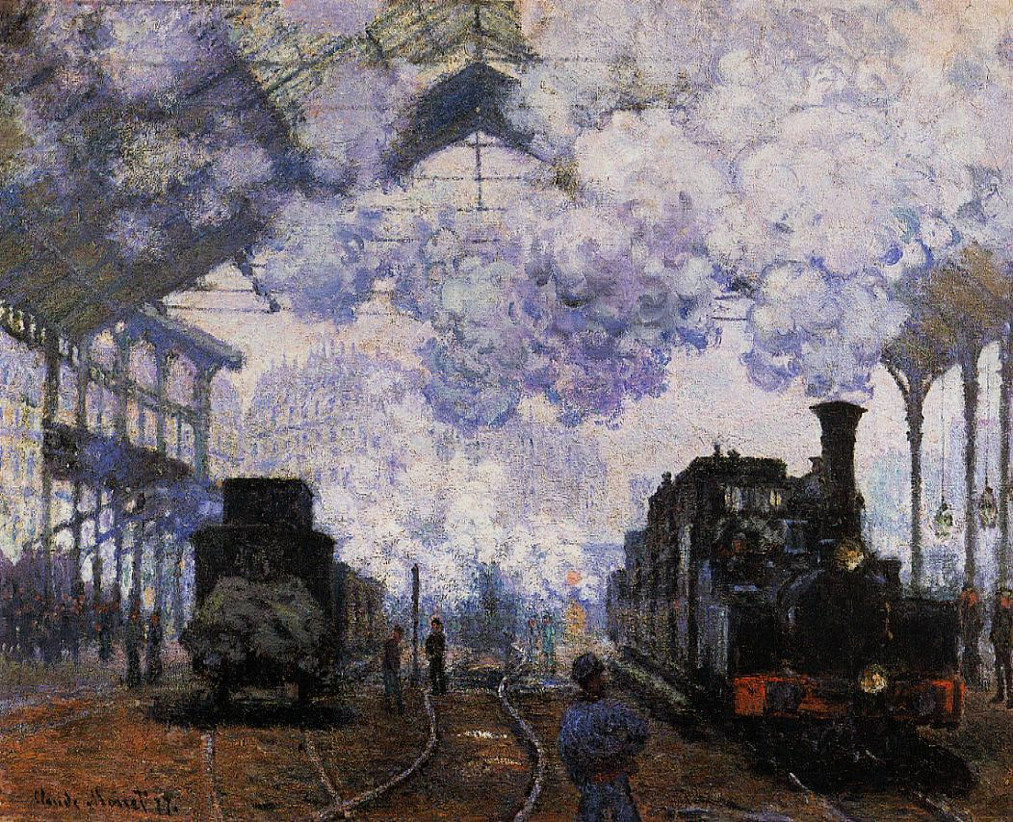
The steam engine, it turns out, also sparked innovative methods of transportation. Railways were not new in pre-industrial Britain. There were over 1,000 railways by 1800, most of them connected to an iron pit or a coal mine with a canal or river. But all of these railways were drawn by horses (Weightman 118). In fact, horses were the best form of land transportation in Eurasia since the beginning of time; the only other option was to walk. Steam would change all that.
The first full-scale steam-powered locomotive took its maiden voyage down the main street of Camborne, England on Christmas Eve in 1801. The Cornish “puffer” drove like a car without rails and was the brainchild of Richard Trevithick. After the first run, the inventor parked it in a shed and went to celebrate his success. Unfortunately, he forgot to turn the boiler off and the entire shed and locomotive were destroyed in a fire. But Trevithick got another chance. An ironworks owner built a nine-mile railway to compete with a canal. Horses pulled cars full of iron and coal along the rails. In a competition, Trevithick’s Cornish “puffer” succeeded in hauling ten tons of bar iron and seventy passengers along rails at a speed of five miles per hour. Sadly, Trevithick could never turn the invention into financial success: he died in Peru failing in his attempt to seek his fortune in silver mines (Weightman 48-49, 58-9).
A young self-taught engineer, George Stephenson, picked up where Trevithick left off. Stephenson was raised in coalfields, where his family worked. He took jobs there, first working in the mines with a pick and then working on an old Newcomen steam engine that pumped water out of mine shafts. Stephenson grew up illiterate, like the rest of his family, but, as a teenager, taught himself to read and hired a tutor to teach him basic math. To make extra money, he learned to repair watches. At 22 years old, Stephenson was put in charge of running a Watt steam engine at a spinning factory. Over the following years, he taught himself mechanical engineering by taking apart steam engines and other machines,putting them back together. He took out patents on a steam engine locomotive and iron rails in 1816. He succeeded in improving upon Trevithick’s puffer, but his big break came as the result of the fast-growing cotton industry in Manchester (Rosen 298- 305).
In 1825, Stephenson was commissioned to construct a 30-mile railway line from Liverpool to Manchester. Manchester was the largest industrial town in the world, and merchants needed to transport lots of cotton and finished cloth. Despite its young age, Liverpool, as the port for the Manchester cotton industry, handled one third of the world’s trade (Rosen 298- 305). Stephenson surveyed the route and built the railway. He set the distance between the two tracks at four feet, eight and a half inches, because it happened to be the width of some coal-mining cars—and this would become the worldwide standard railroad gauge.
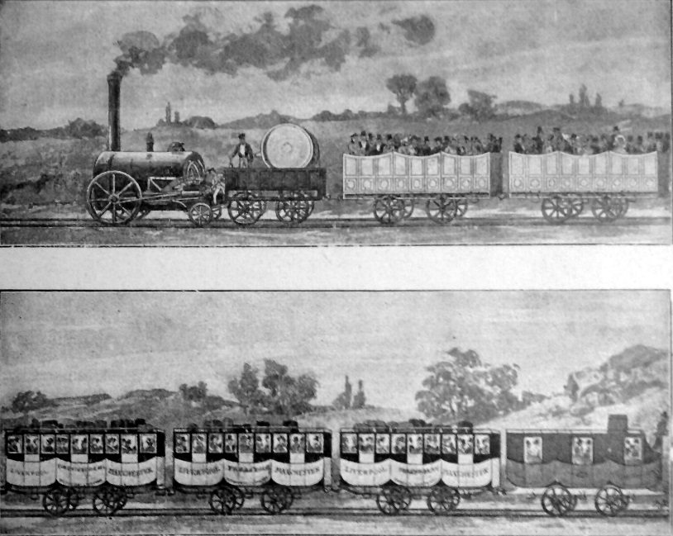
In 1829, the railway owners sponsored a contest to find out who could make the fastest and most reliable locomotive to run on the newly built Manchester-to-Liverpool railway. Most contestants entered steam-powered vehicles, but one underdog participant actually used a horse trotting on a treadmill attached to a car. A man named George and his son, Robert, called their locomotive the Rocket. They defeated five competitors and reached average speeds of at least 29 miles per hour. On the day the Manchester-to-Liverpool railroad was opened to the public, a member of Parliament and a supporter of the railway was accidently killed by the Rocket. In a failed attempt to save the gentleman’s life, Stephenson opened up the throttle to top speed and made a heroic dash to a hospital in the next town—and he averaged 35 mph for 15 miles. The competition garnered much attention in England and Europe; Stephenson and other top competitors took offers for their new locomotives from as far away as Russia. In 1831, just two years after the race, the Liverpool-to-Manchester railway carried 450,000 passengers, 43,000 tons of cotton, and 11,000 tons of coal. By 1835, the railway carried 120,000 tons of coal (Weightman 132-134; Rosen 301 to 310)
http://webs.bcp.org/sites/vcleary/ModernWorldHistoryTextbook/IndustrialRevolution/videostephensonrocket.html This silent movie used a replica of Stephenson's Rocket. It gives you a sense of the size and speed of the famous train.
http://webs.bcp.org/sites/vcleary/ModernWorldHistoryTextbook/IndustrialRevolution/IRbegins.html
https://www.youtube.com/watch?v=d4joqYycnqM Industrial Revolution Video Clip
1879—Edison invents electric light

Thomas Edison – Changing our World Forever
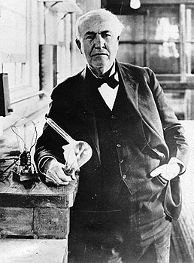
It is hard for most people today – at least those of us in so-called “developed countries” – to remember or even imagine a world without telephones, movie theaters, recorded music or even electric lights. But that was the world when Thomas Edison was born in 1847.
As a child, Edison was extremely inquisitive, but also something of a dreamer (if modern psychology had existed at the time, he would probably have been diagnosed with ADD!).
By the age of 12 he was working on the Grand Trunk railway, where on one occasion his quick actions saved a child’s life. In gratitude, the child’s father taught him Morse code and the operation of the telegraph. In those days (1863) this was the equivalent of being trained to use and program a state-of-the-art computer today!
Tom immediately began tinkering with the technology, learning all he could about it, and finding ways to improve it or expand its principles into other areas.
By his early twenties, he had already registered patents on several of his own inventions, and sold the rights to an improved stock ticker, making him wealthy. He was now in a position to explore any field he wanted.
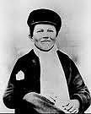
Over the next few years, he formed a team of researchers and inventors to work for him and continued to invent and patent a number of successful inventions. One of the most successful was a new carbon microphone which finally made Alexander Bell’s new “telephone” device loud enough and clear enough for practical use. (This same technology was still widely used in telephones right up to the 1980s.)
Edison moved his laboratory to Menlo Park, N.J., and within a year, the sprawling complex was the largest scientific testing laboratory in the world. He was one of the first to apply the principles of mass production and large teamwork to the process of innovation. Ultimately, he secured over 400 patents on the work done here and is regarded as one of the most successful idea incubators in history.
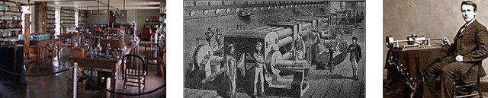
His wide-ranging curiosity took his research in many directions. For example, in 1877, more or less out of the blue, he invented the phonograph…a way of recording voices and music onto fragile wax cylinders. This new technology so amazed and excited the public imagination that Edison became immediately famous for it.
But a year later he put it on the back shelf for over a decade, as an even bigger opportunity now occupied his attention: the search for a practical, reliable form of electric lighting.
In truth, Edison didn’t actually even “invent” the light bulb; a number of other inventors had developed forms of electric lighting before he began his experiments. He simply found a better material (carbonized thread) to use as the filament.
If I find 10,000 ways something won’t work, I haven’t failed. I am not discouraged, because every wrong attempt discarded is another step forward.
– Thomas Edison
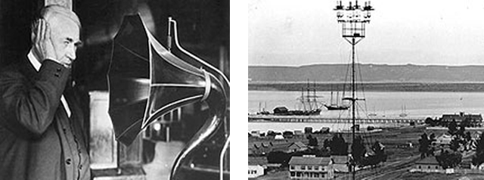
No, his real achievement was far bigger: making electric light commercially practical.
Because before his new bulb would do anyone any good, Edison had to invent an entire electrical distribution system that could support city-sized populations.
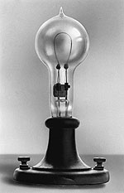
Specifically, there were at least 7 essential technologies to be invented before incandescent lights would be practical, safe, and economical.
- the parallel circuit,
- a better dynamo,
- some form of voltage stabilizer,
- a conductor network to distribute the power
- safety fuses and insulating materials,
- light sockets with on-off switches.
- And then…a durable light bulb.
And you guessed it: none of that existed at the time. Nor did generating stations, transmission lines, transformers or outlets to plug anything into.
Before this brand new technology could change the world, every one of these elements had to be first invented – and then developed into practical, reproducible components, deployed and integrated, and finally rolled out commercially.
Think how long and arduous such an undertaking would be, even today!
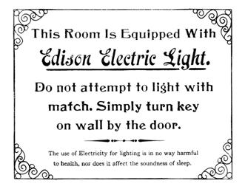
How long did it take Edison and his team? Just four years.
Four years, from the first successful light bulb in a laboratory to the first generating station, supplying 85 customers in New York City.
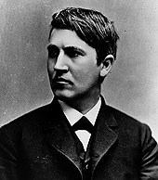
And after that, the growth was exponential: one year later, he had 550 customers, with almost 11,000 electric lights, and was opening a second generating station. He had also established Edison companies to handle each part of the electricity supply chain.
But other, competing technologies were now challenging his. In particular, while Edison continued to champion DC (Direct Current), it had severe voltage loss problems when transmitted over distance, making AC a better choice. While the two co-existed for a while, eventually, it was AC which came to dominate.
In 1982, Edison General Electric Company went through a merger and became General Electric. Past that point Thomas himself had no further involvement in the electricity business.
Of course, he was far from finished changing the world!
He immediately went on to develop some of the first motion picture technologies, producing not just the equipment or the projectors, but also the content, in the form of hundreds of short films.
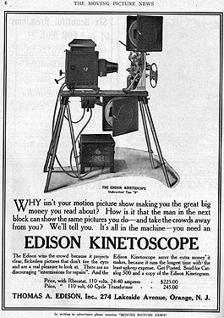
Once again, he had to invent (and patent!) every link in the chain. And once again he managed to find huge success in the process. Edison’s name became almost synonymous with sound recordings and motion pictures in the early years of the 20th century.
It is no coincidence that Apple followed the Edison “own the whole chain” model when they rolled out the world-changing iPhone and iTunes. Edison has always been one of Steve Jobs’ heroes.
So what made Thomas Edison tick?
How did he manage to think on so many levels, and conquer problems that seemed insoluble to others?
He said that his experimental method was built on the presumption that there are no failures – that because it teaches you something, every outcome is a successful outcome.
I never quit until I get what I’m after. Negative results are just what I’m after. They are just as valuable to me as positive results.
– Thomas Edison
So here is my question to you:
What would you be capable of, if you knew that you could never fail?
How high could you reach if you believed that there were no wrong answers, and that you could learn as much from taking the wrong trail as by sticking to the one you knew?
Maybe more important, if you are a business leader – what could your people do if they really believed that they could not fail?
One of the greatest impediments to innovation in business today is a fear of failure that did not exist even 30 years ago. Failures cost money, and Wall Street is too often more interested in today than tomorrow. Too bad. There are very few companies out there that can truthfully say that they are unafraid to fail. And that is why there are so few real innovators.
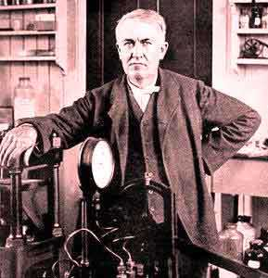

Thomas Edison showed us that if you treat every result as a positive result, then you set yourself up for success. If that is your mindset, you literally cannot fail. http://www.themarkofaleader.com/library/stories/thomas-edison-changing-our-world-forever/
https://www.youtube.com/watch?v=ZlxVDdBtFQQ Video Clip
https://www.youtube.com/watch?v=VVL8ptff7yI Video Clip

