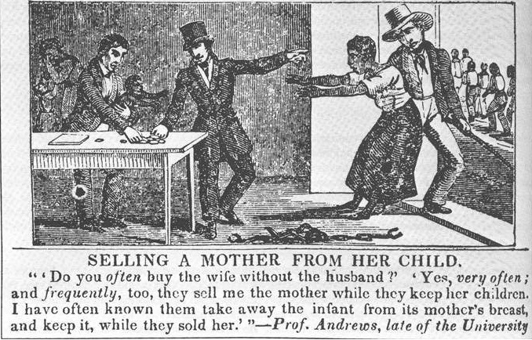
http://ideologicalart.files.wordpress.com/2011/12/antislavery-comic.jpg

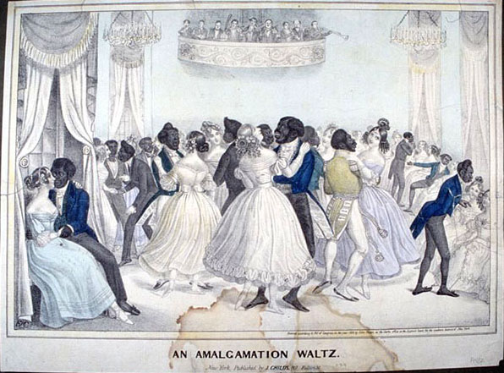
http://utc.iath.virginia.edu/xml/pretexts/gallery/figures/aas02.jpg
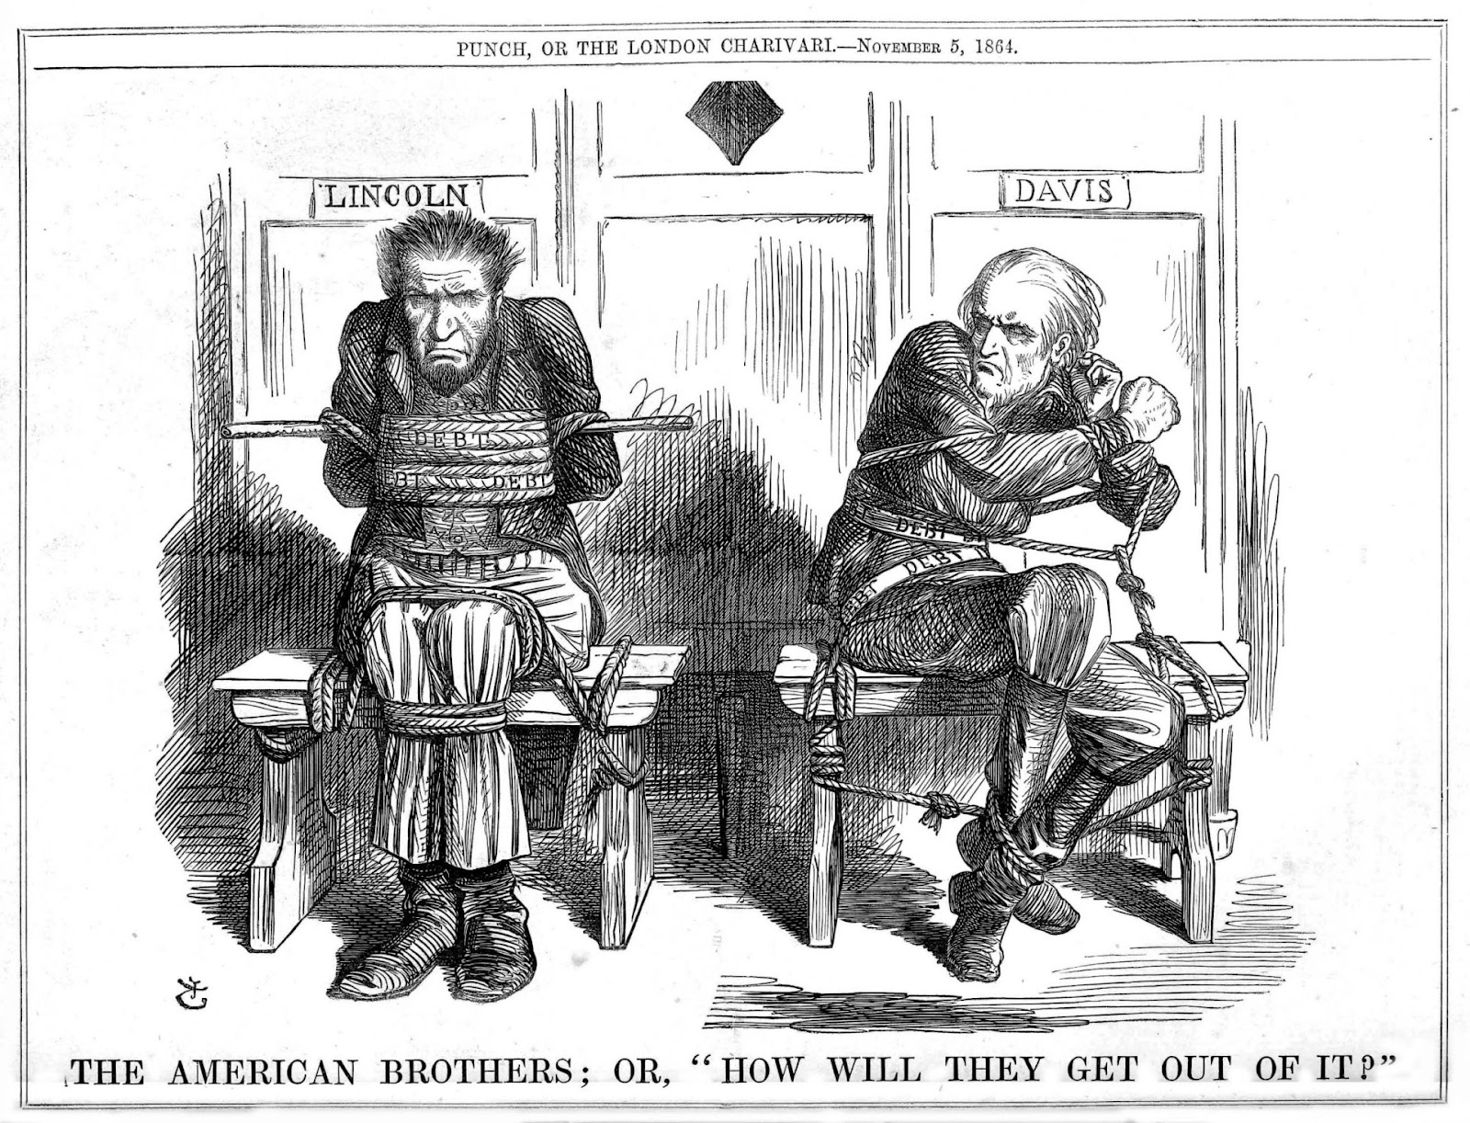
http://4.bp.blogspot.com/-h1y9qflt7XU/T3-k6ax5EwI/AAAAAAAAZkk/HEWVYdHBzxY/s1600/010_PUNCH_Nov_5_1864.jpg
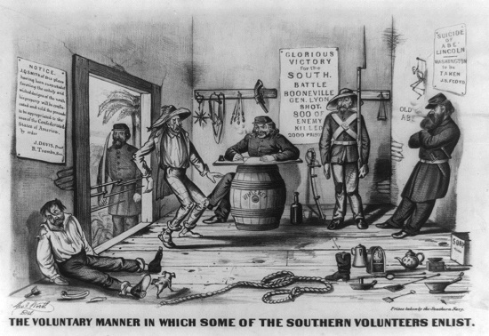
http://2.bp.blogspot.com/-p3hQ-n23MXM/Tl92M3oXCaI/AAAAAAAABCI/-8DOnv__yCU/s1600/recruitment.jpg

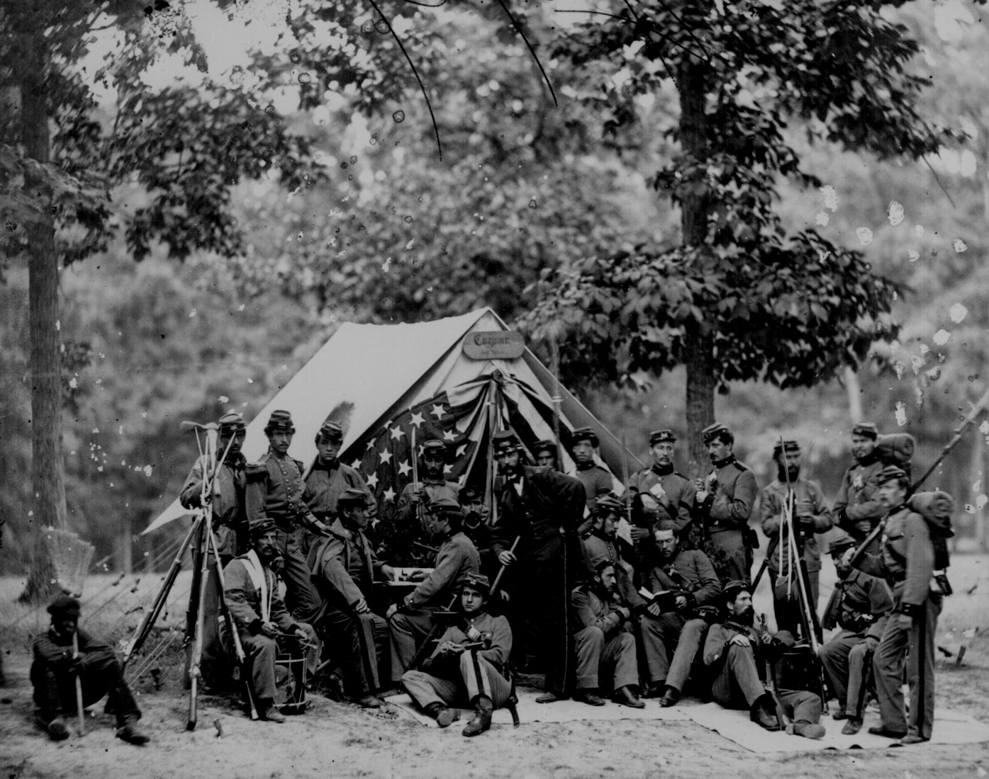
Engineers of the 8th N.Y. State Militia, 1861. No. Ill-B-499. Cropped from Select List # 5.
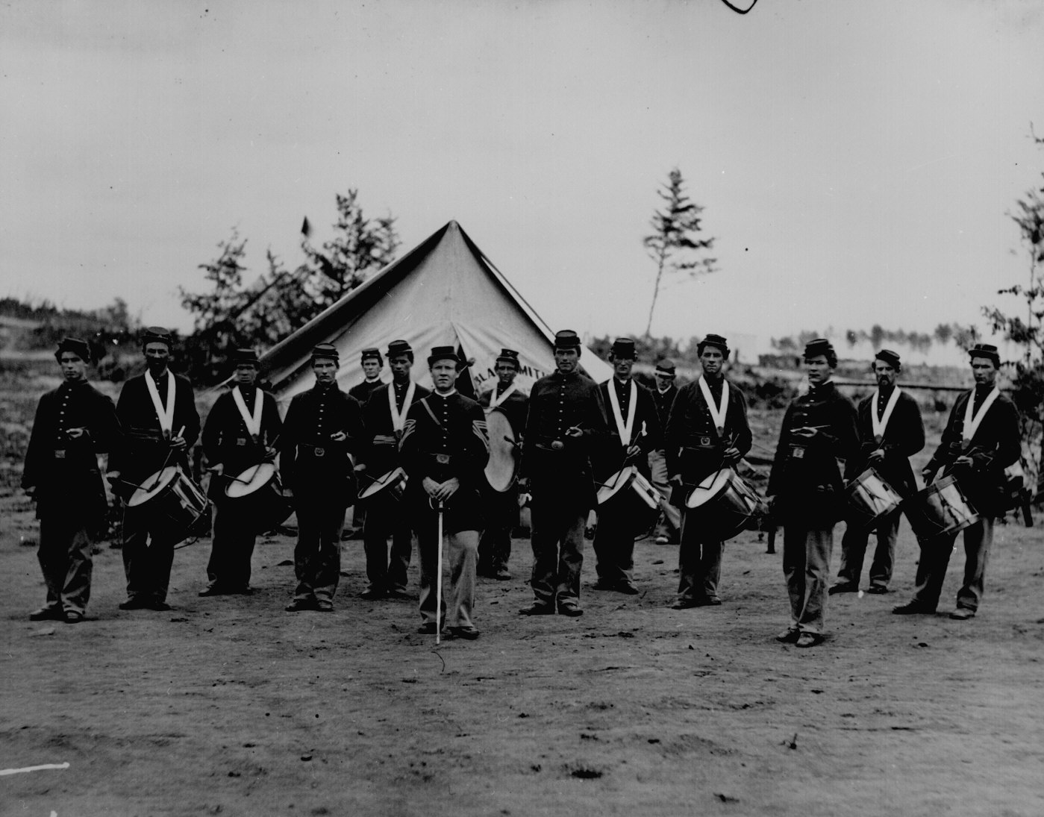
A regimental fife-and-drum corps. 111-B-328.
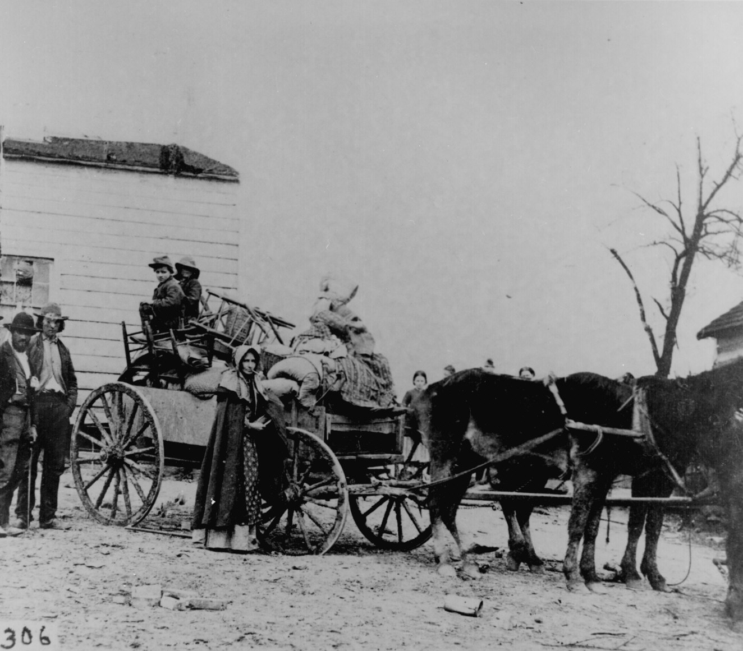
A refugee family leaving a war area with belongings loaded on a cart. 200-CC-306.
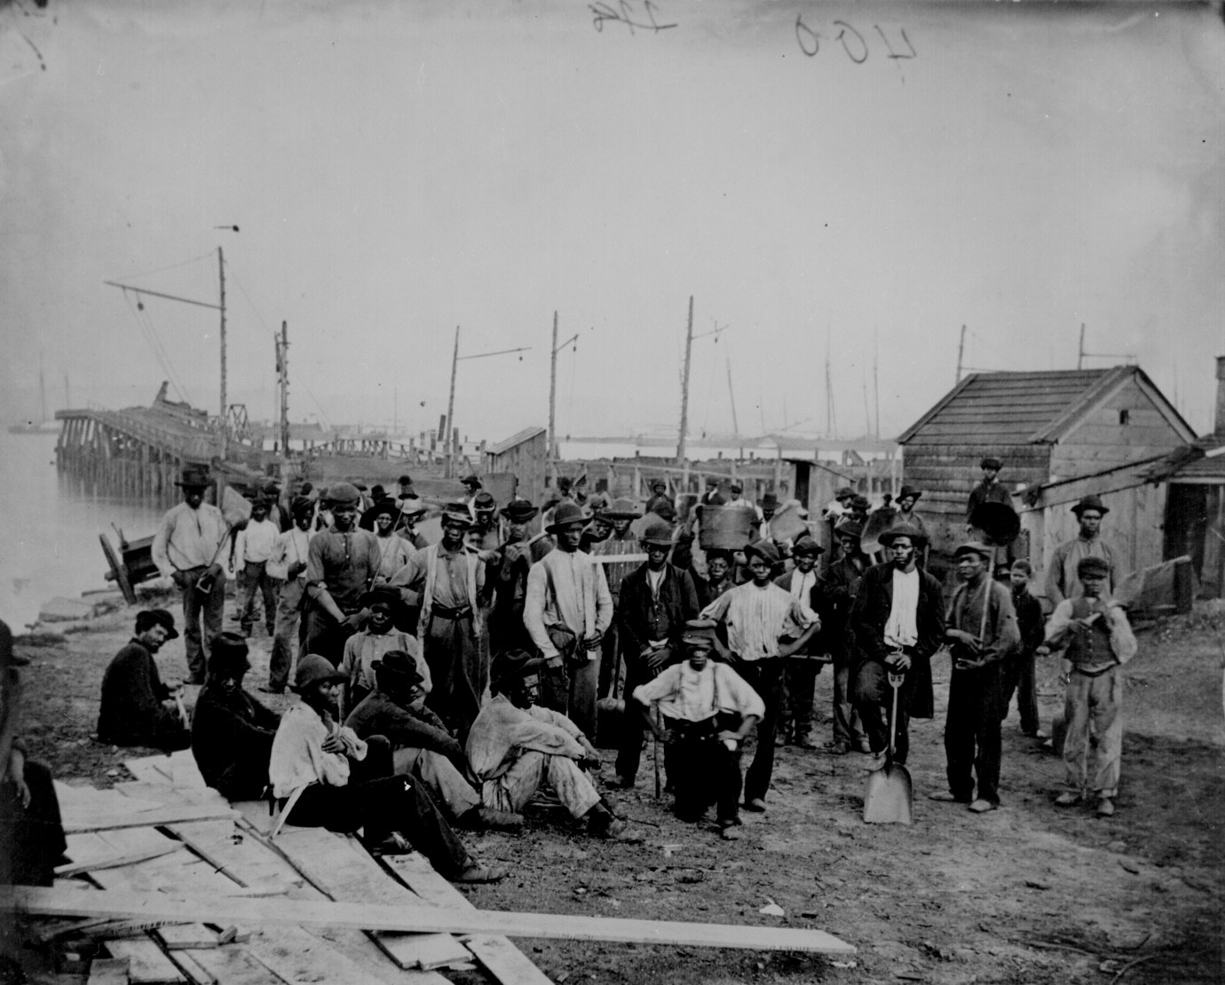
Black laborers on a wharf, James River, Va. 111-B-400.
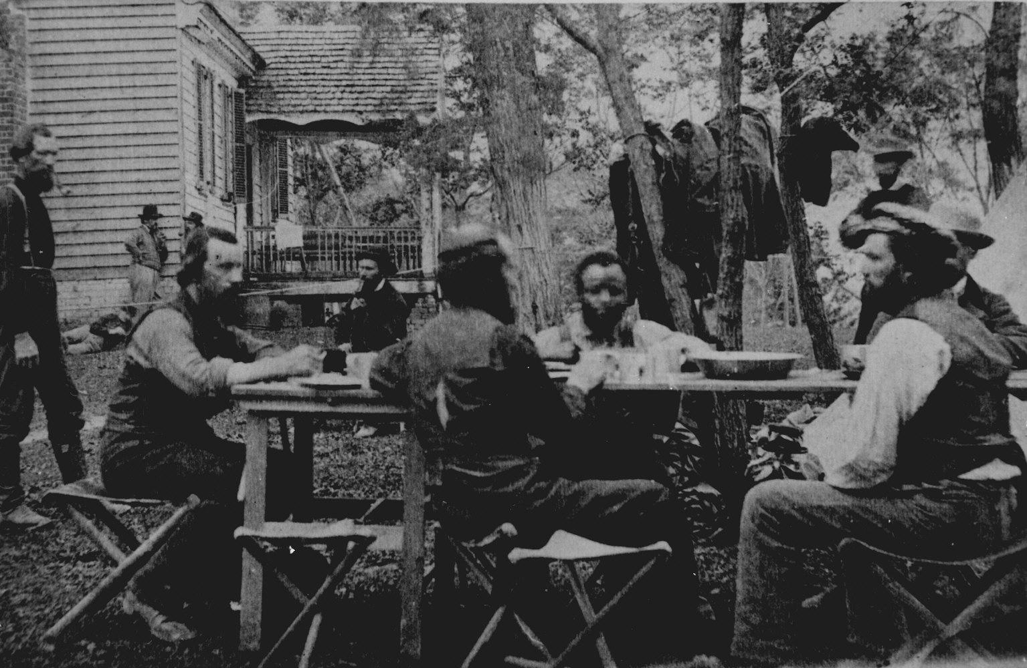
Allan Pinkerton, chief of McClellan's secret service, with his men near Cumberland Landing, Va., May 14, 1862. (Pinkerton is smoking a pipe.) Photographed by George N. Barnard and James F. Gibson. 90-CM-385.
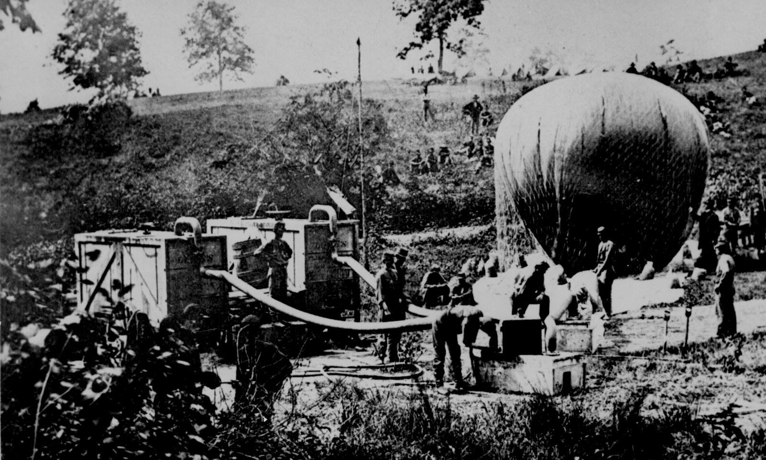
Federal observation balloon Intrepid being inflated. Battle of Fair Oaks, Va., May 1862. 111-B-680.
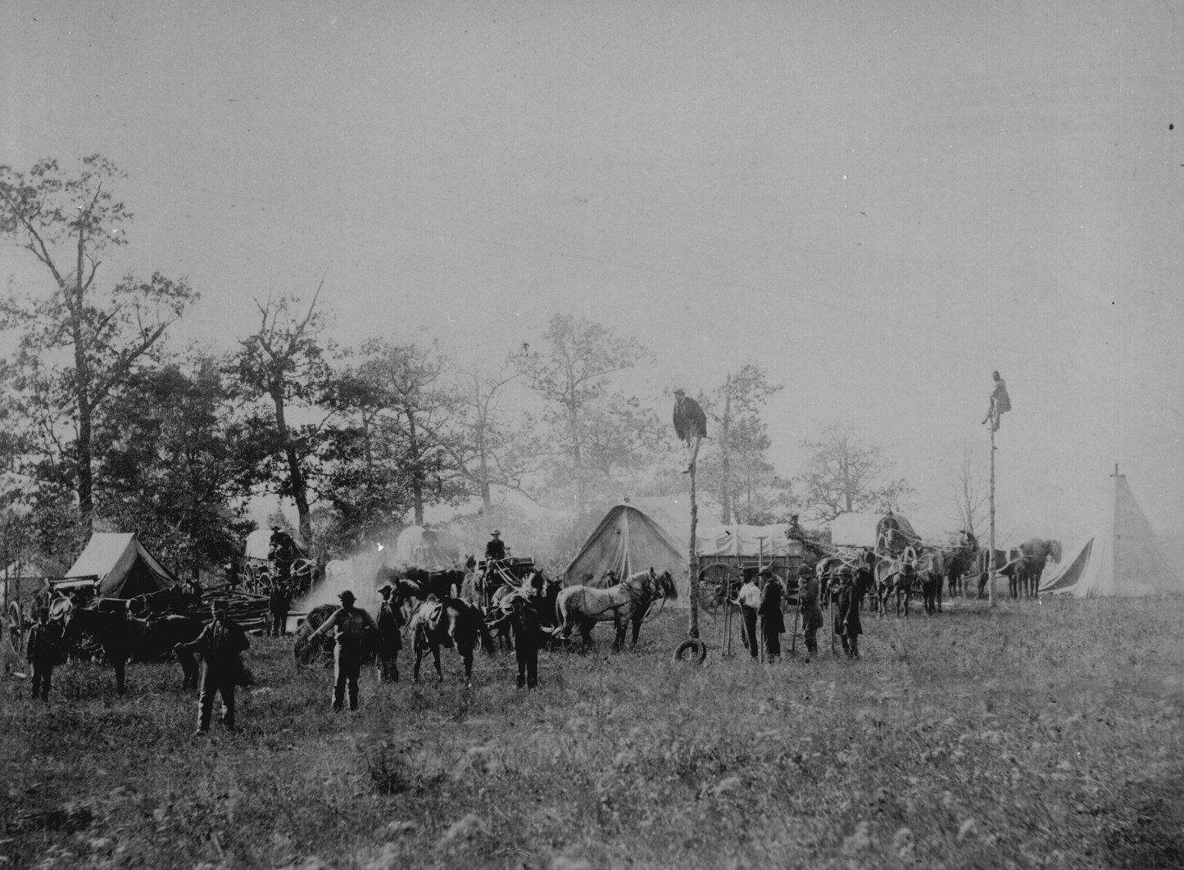
Constructing telegraph lines, April 1864. Photographed by Timothy H. O'Sullivan. 165-SB-62.
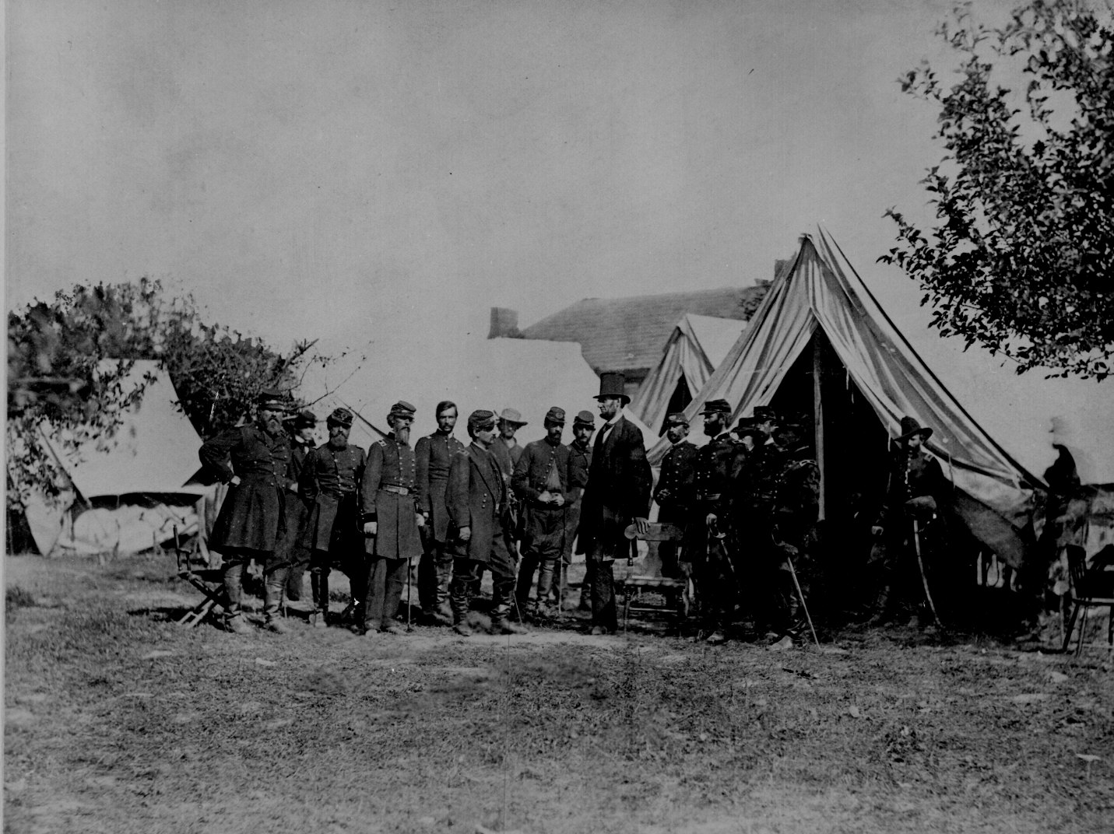
President Lincoln visiting the battlefield at Antietam, Md., October 3, 1862. General McClellan and 15 members of his staff are in the group. Photographed by Alexander Gardner. 165-SB-23.
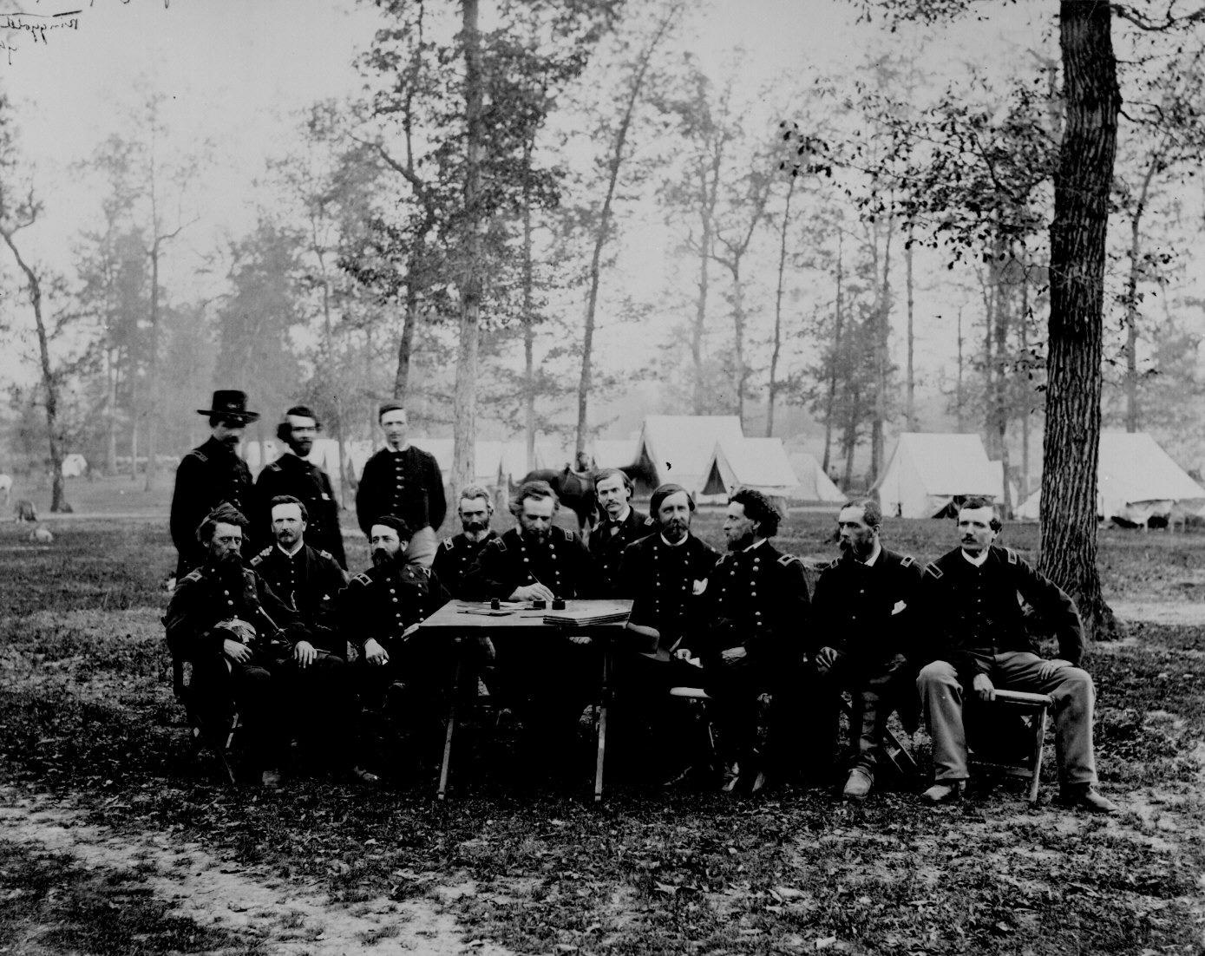
Gen. George Thomas and a group of officers at a council of war near Ringgold, Ga., May 5, 1864. 77-HMS-344-2P.
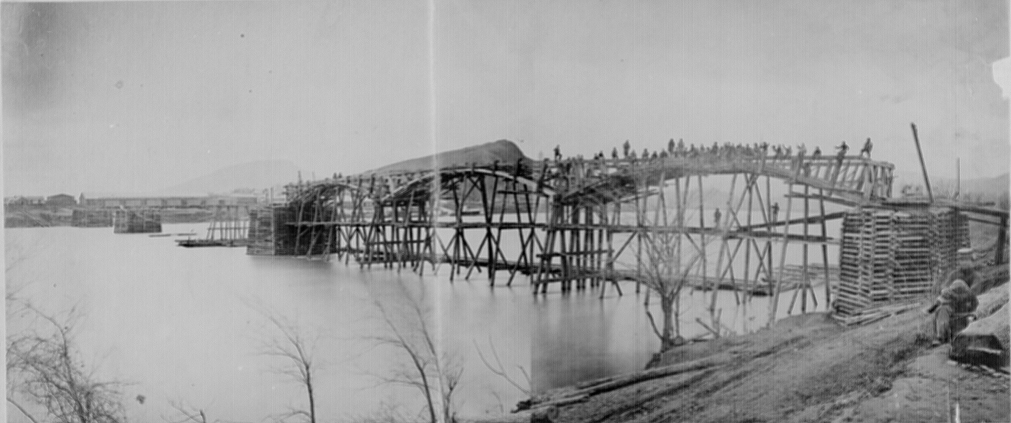
Federal engineers bridging the Tennessee River at Chattanooga, March 1864. 77-F-147-2-6.
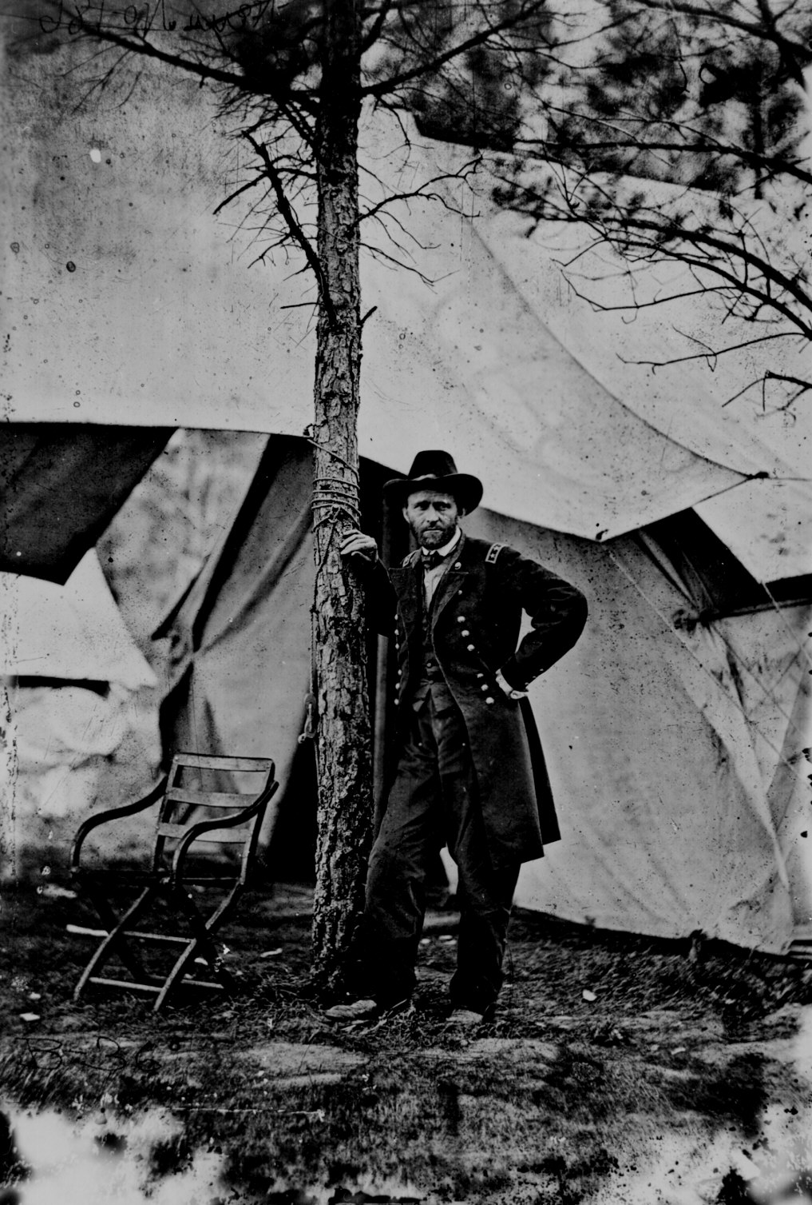Lt. Gen. Ulysses S. Grant standing by a tree in front of a tent, Cold Harbor, Va., June 1864. 111-B-36.
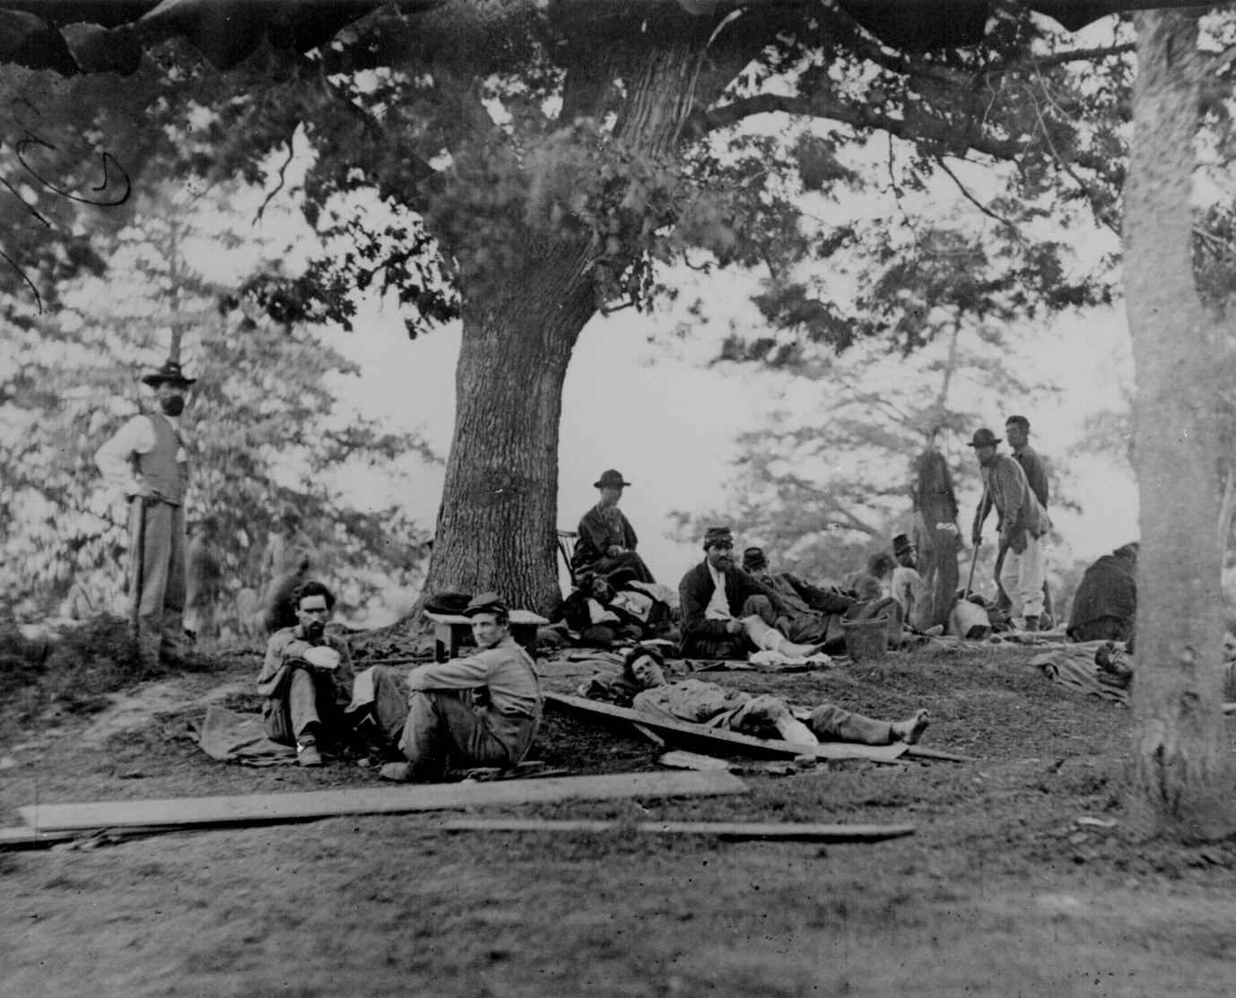
Wounded soldiers being tended in the field after the Battle of Chancellorsville near Fredericksburg, Va., May 2, 1863. 111-B-349.
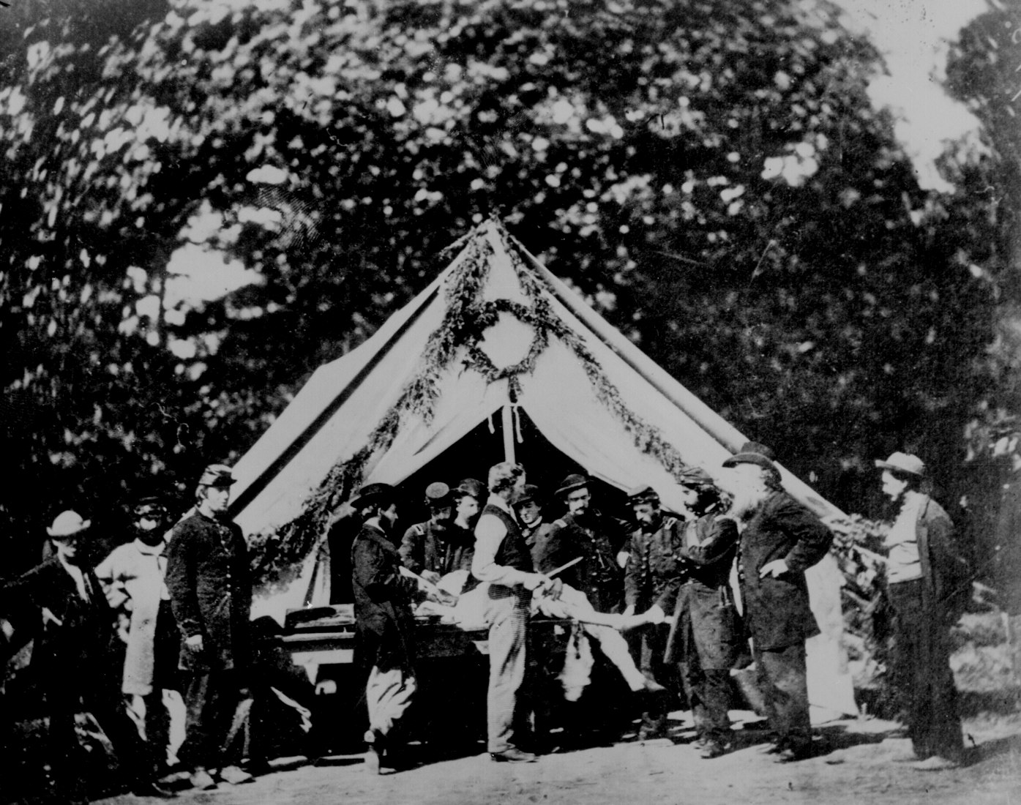
Amputation being performed in a hospital tent, Gettysburg, July 1863. 79-T-2265.
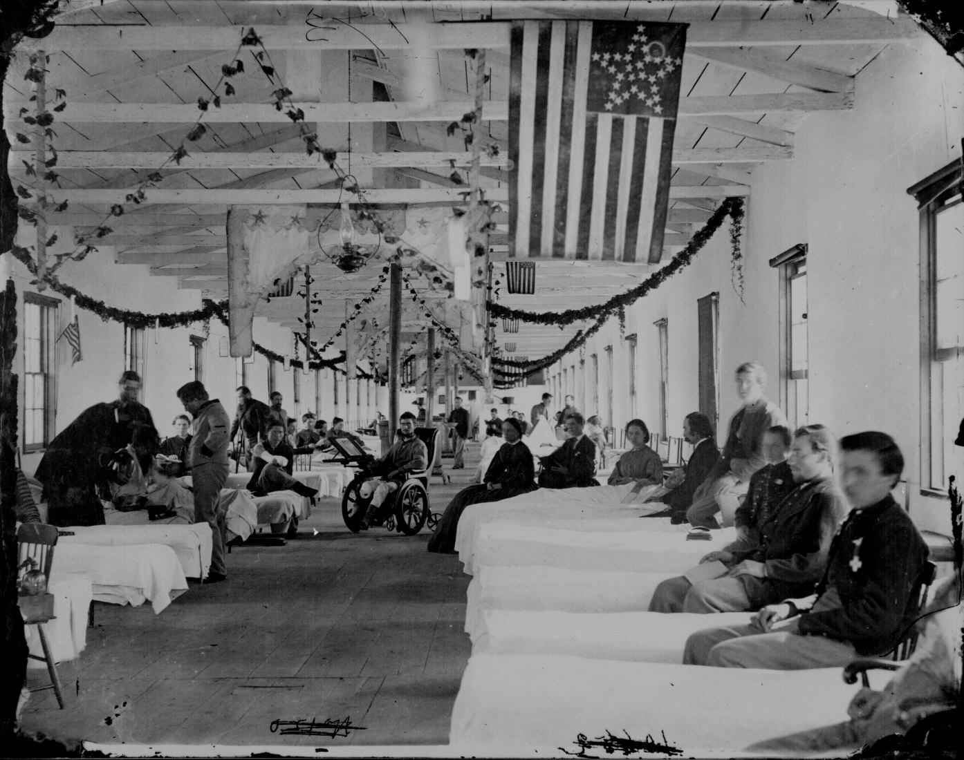
Ward in the Carver General Hospital, Washington, D.C. 111-B-173.
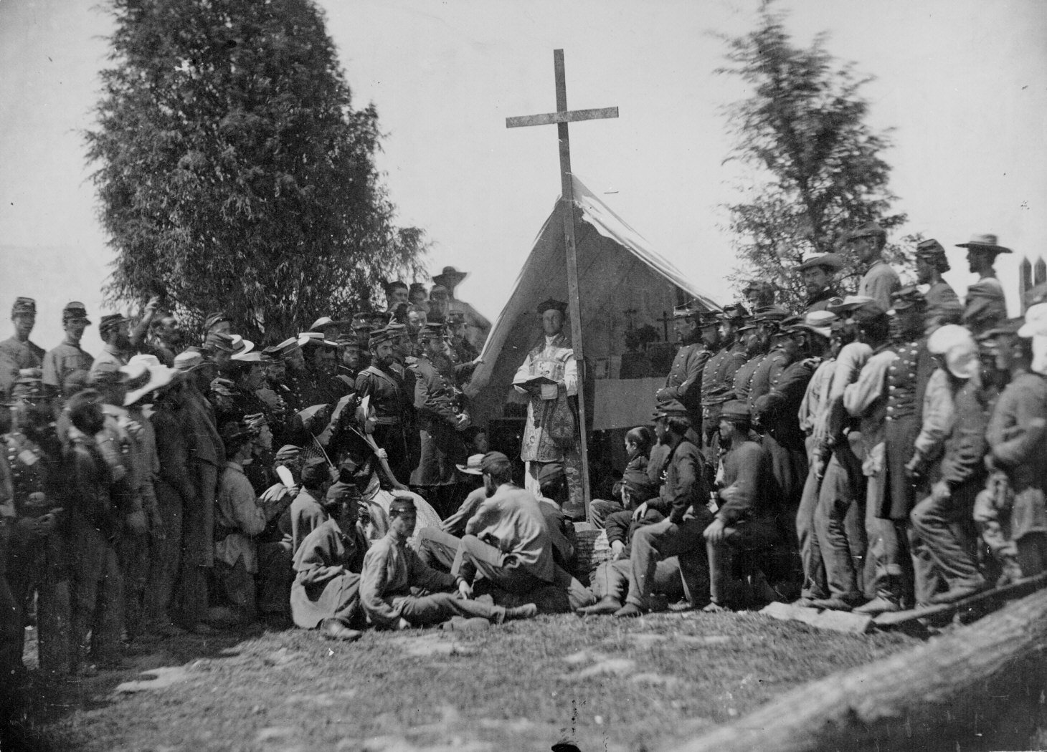
Chaplain conducting mass for the 69th New York State Militia encamped at Fort Corcoran, Washington, D.C., 1861. Photographed by Mathew B. Brady. 165-C-100
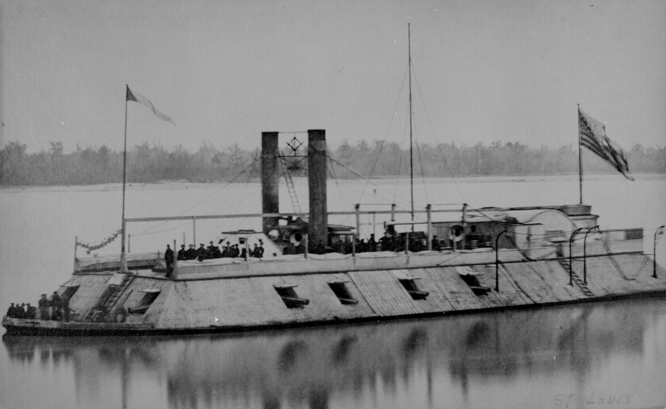
U.S.S. St. Louis, first Eads ironclad gunboat, renamed the Baron de Kalb in October 1862. 165-C-630.
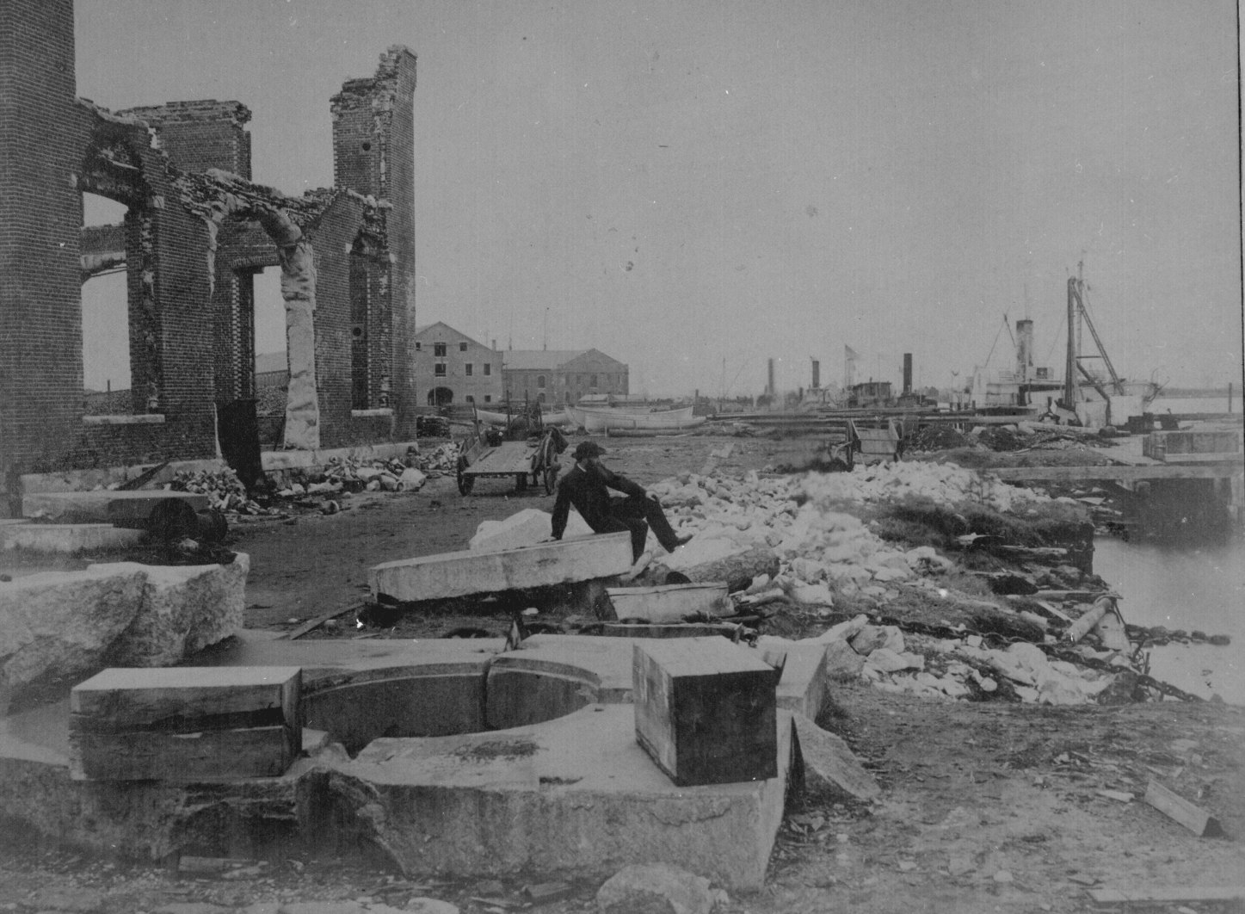
Ruins of the navy yard at Norfolk, Va., December 1864. Photographed by James Gardner. 165-SB-18
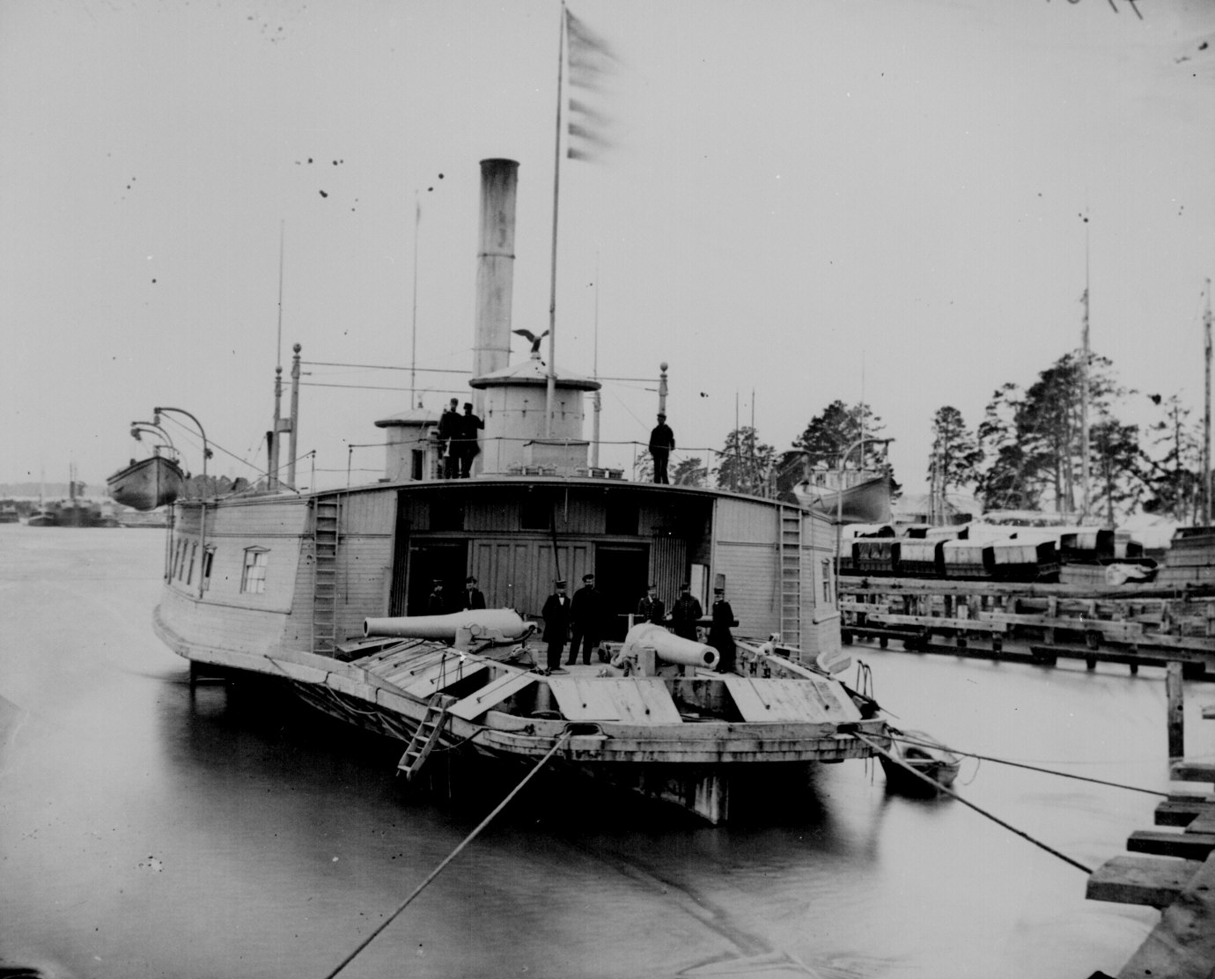
U.S.S. Commodore Perry, a ferryboat converted into a gunboat, Pamunkey River, Va., 1864. 111-B-411.
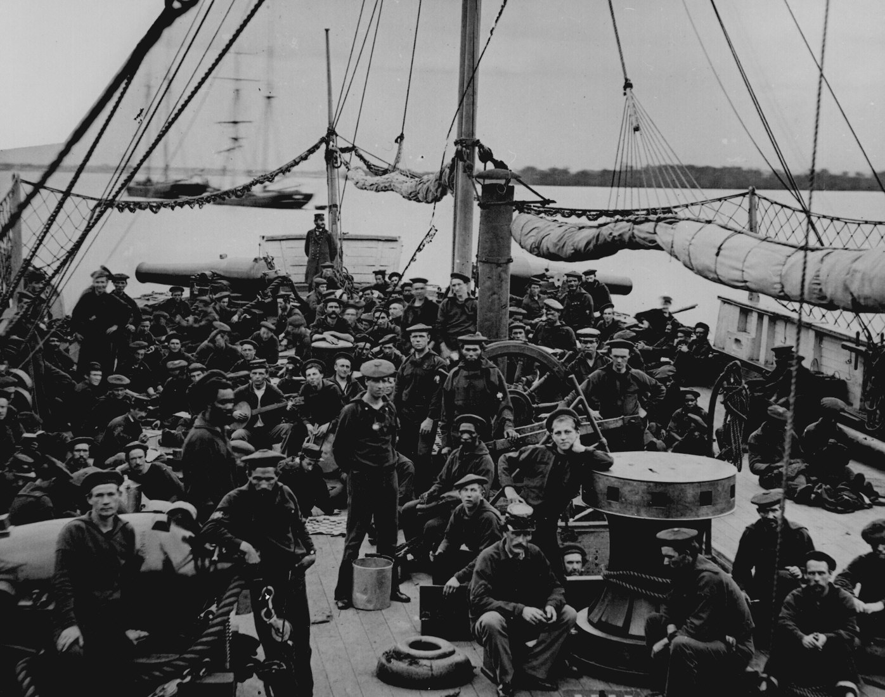
Sailors and marines on the deck of the U.S. gunboat Mendota, 1864. 111-B-129.
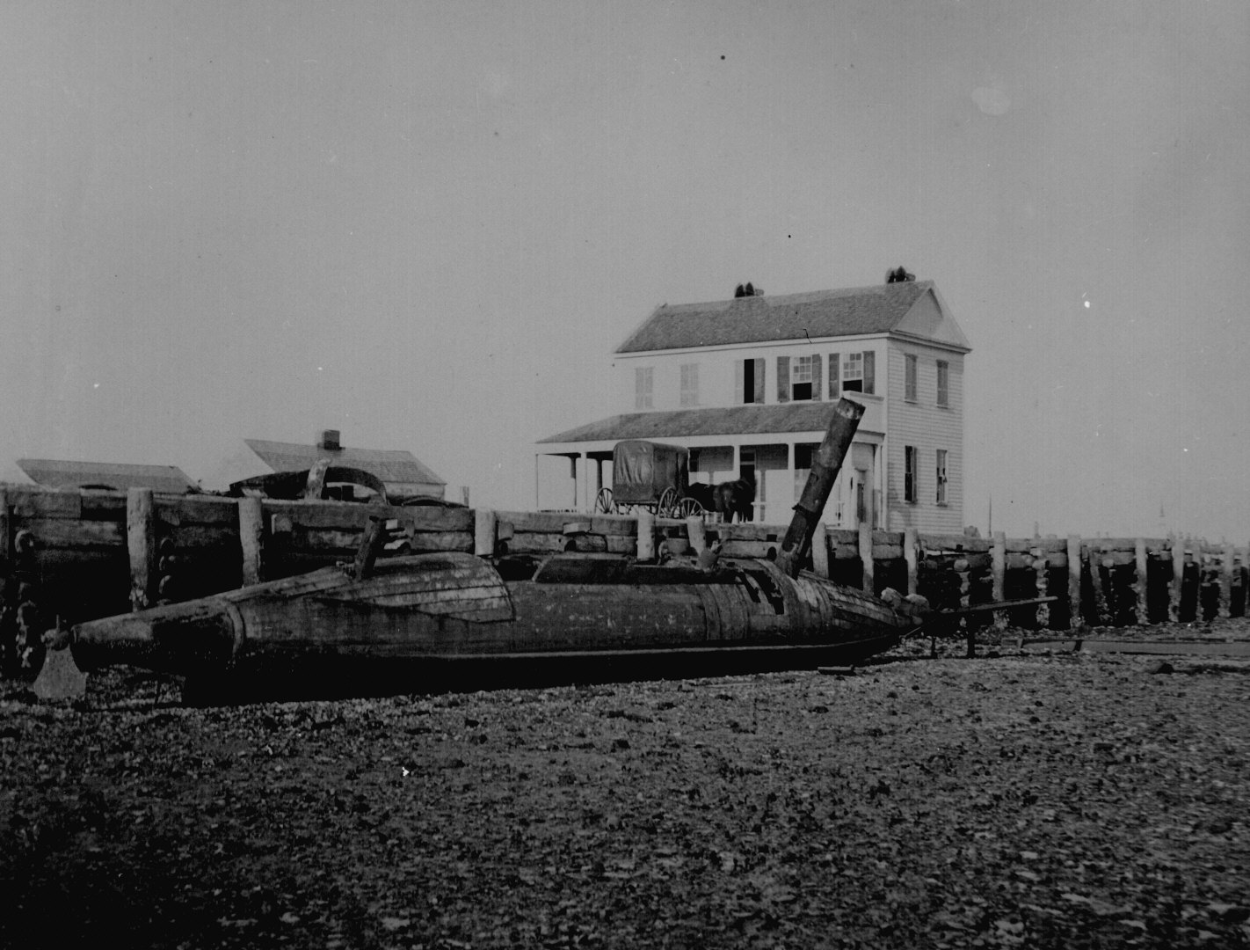
Confederate torpedo boat David aground at Charleston, S.C., 1865. Photographed by Selmar Rush Seibert. 165-C-751.
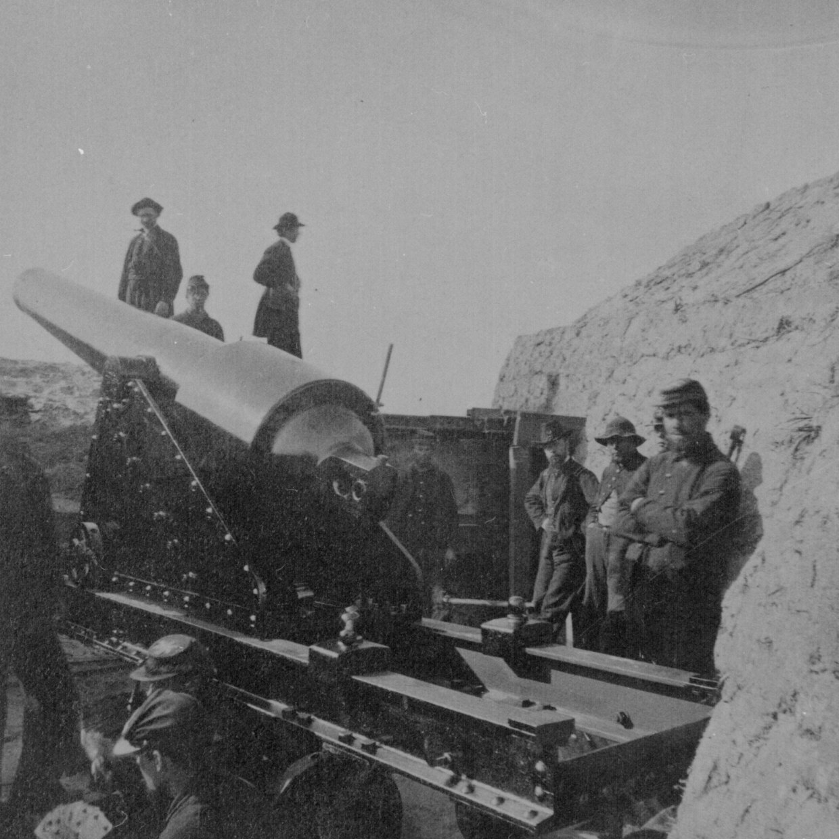
A 200-pound Parrott rifle in Fort Gregg on Morris Island, S.C., 1865. Photographed by Samuel A. Cooley. 165-S-128.
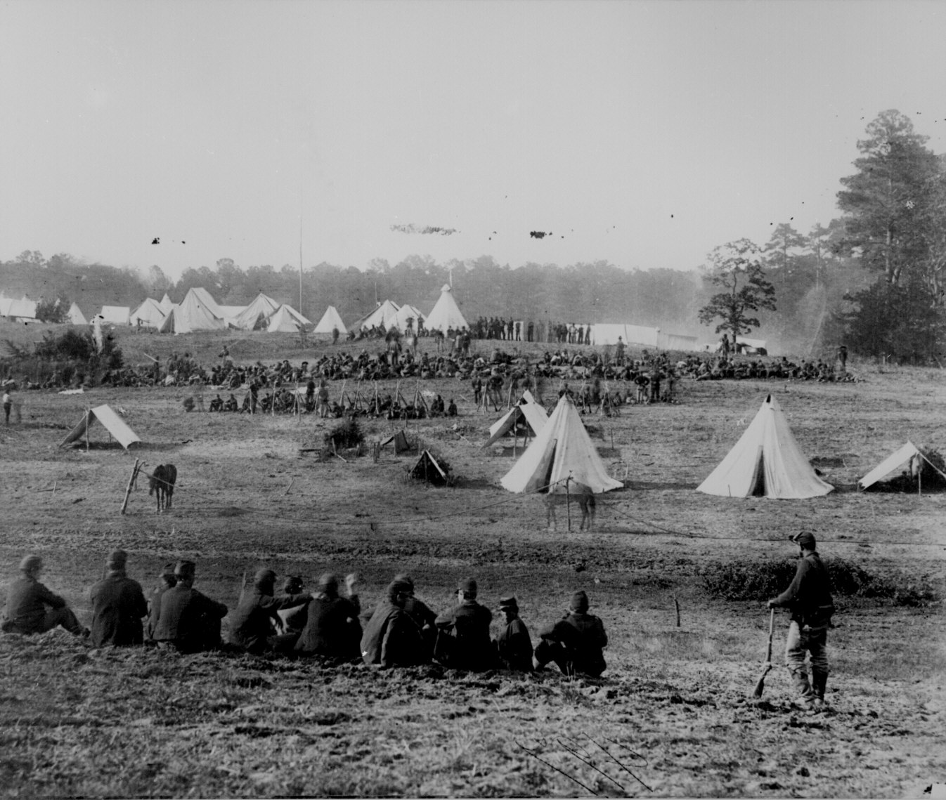
Confederate prisoners captured in the Shenandoah Valley being guarded in a Union camp, May 1862. 111-B-497.
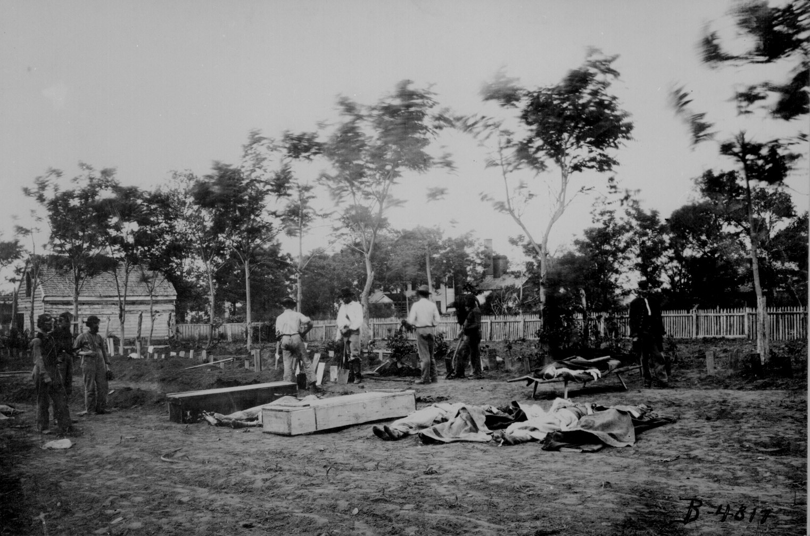
Burying the dead at Fredericksburg, Va., after the Wilderness Campaign, May 1864. Photographed by Timothy H. O'Sullivan. 111-B-4817.
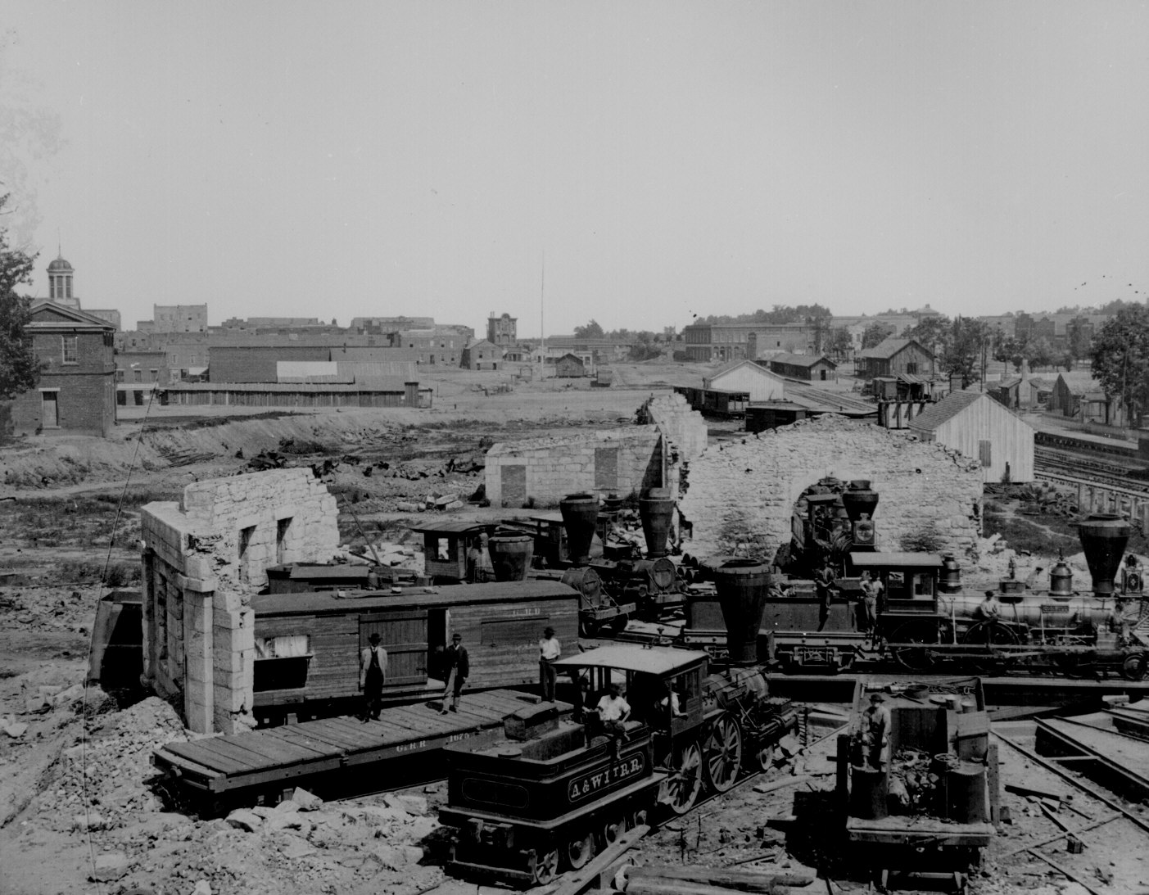
Ruins of the Confederate enginehouse at Atlanta, Ga., September 1864, showing the engines "Telegraph" and "O.A. Bull." 111-B-4748.
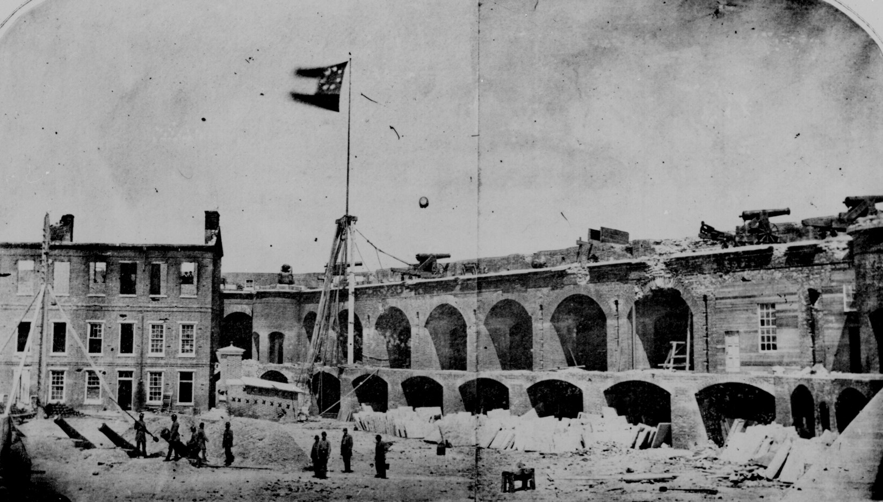
Fort Sumter, S.C., April 14, 1861, under the Confederate flag. 121-BA-914A.
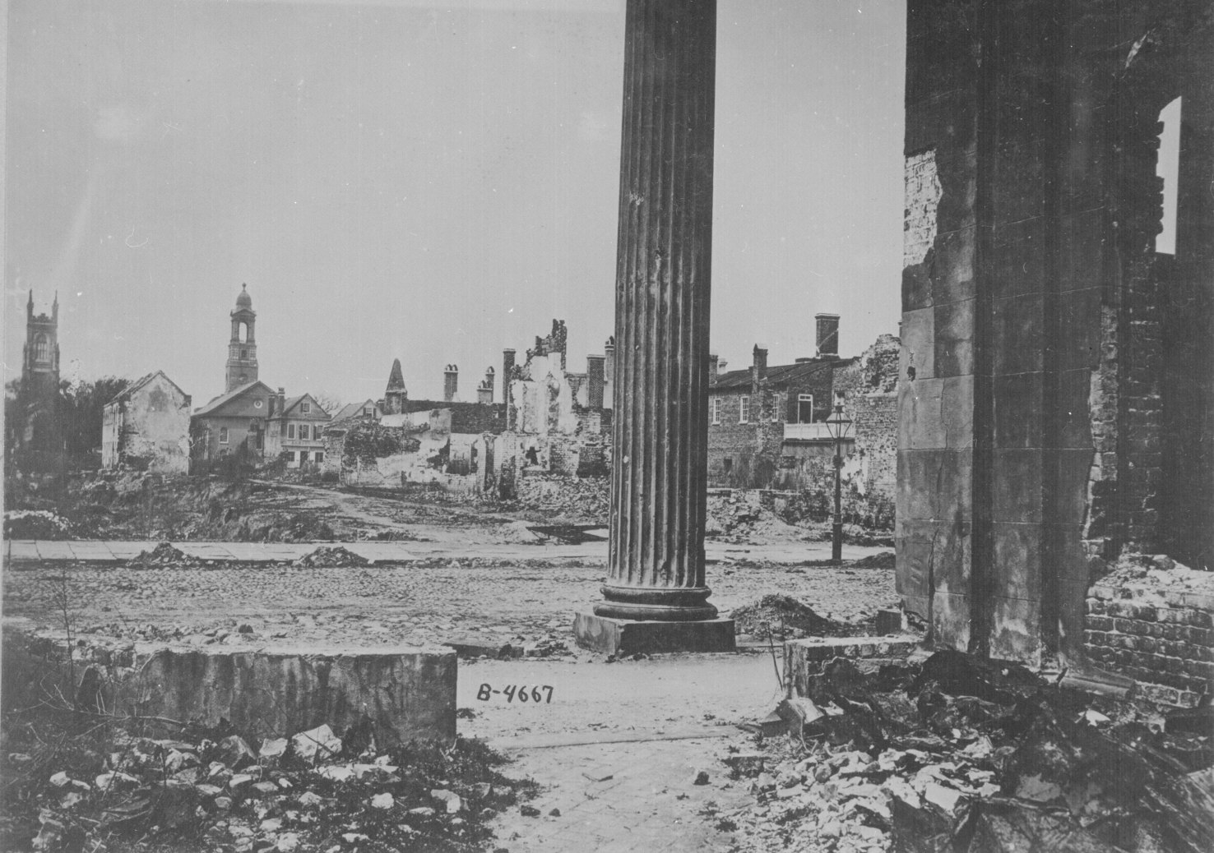
Ruins seen from the Circular Church, Charleston, S.C., 1865. 111-B-4667.
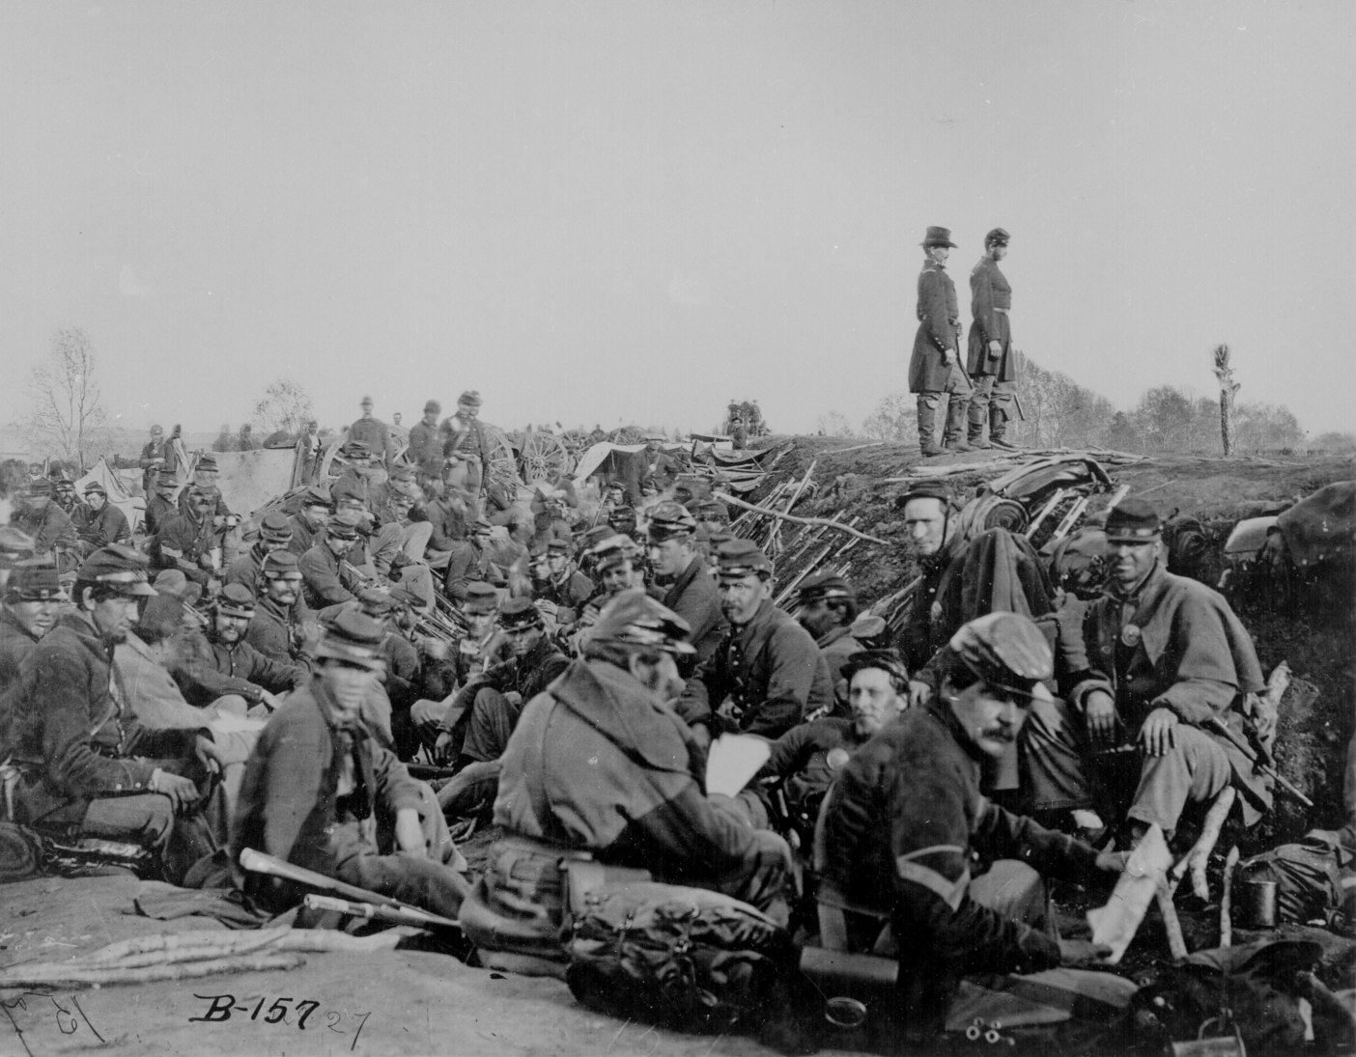
Soldiers in the trenches before battle, Petersburg, Va., 1865. 111-B-157.
CIVIL WAR ERA SLANG AND TERMS
Absquatulate - to take leave, to disappear
Acknowledge the Corn - to admit the truth, to confess a lie, or acknowledge an obvious personal shortcoming
Arkansas Toothpick - a long, sharp knife
A.W.O.L. - Absent With Out Leave
Bad Egg - bad person, good for nothing
Balderdash - nonsense
Bark Juice, Red Eye, O Be Joyful - liquor
Beat the Dutch - if that don't beat all
Bluff - trick or deceive
Bragg's Body Guard - lice
Been Through the Mill - been through a lot, seen it all
Bellyache - complain
Big Bugs - big wigs, important people
Bivouac - to camp without formal shelter or in temporary circumstances
Blowhard - braggart, bully
Blue Mass - refers to men on sick call; named after blue pill.
Bread Bag - haversack
Bread Basket - stomach
Bully - exclamation meaning, &'terrific!' or 'hurrah!'
Bully for You - good for you
Bummer – malingerer, someone who deliberately lags behind to forage or steal on his own shrift
Bummer's Cap - regulation army cap with a high/deep crown, so-called because it could be filled with gathered foodstuffs
Bust Head / Pop Skull - cheap whiskey
Camp canard - tall tale circulating around camp as gossip
Cashier - to dismiss from the army dishonorably
Chief Cook and Bottle Washer - person in charge, or someone who can do anything
Chicken Guts - gold braid used to denote officer ranks
Company Q - fictitious unit designation for the sick list
Conniption Fit - hysterics, temper tantrum
Contraband - escaped slaves who sought refuge behind Union lines
Copperhead - Northern person with Southern, anti-Union sympathies
Cracker Line - supply line for troops on the move
Deadbeat - useless person, malingerer
Desecrated Vegetables - Union, dehydrated (desiccated) vegetables formed into yellowish squares
Dog Robber - soldier detailed from the ranks to act as cook
Dog Collar - cravat issued with uniforms, usually discarded
Duds - clothing
Embalmed Beef - canned meat
Essence of Coffee - early instant coffee, found in paste form
Forage - to hunt for food, live off the land; also came to mean plundering enemy property for sustenance
Fit as a fiddle - in good shape
Fit to be tied - angry
Forty Dead Men - a full cartridge box, which usually held forty rounds
French Leave - to go absent without leave
Fresh Fish - new recruits
Go Boil Your Shirt - take a hike, get lost, bug off
Grab a Root - eat a meal, especially a potato
Greenbacks - money
Grey Backs - lice, also derogatory term for Confederate soldiers
Grit - courage, toughness
Goobers - peanuts
Hanker - a strong wish or want
Hard Case - tough guy
Hard Knocks - hard times, ill use
Hardtack - unleavened bread in the form of ¼ inch thick crackers issued by the army
Haversack - canvas bag about one foot square, which was slung over the shoulder and used to carry a soldier's rations when on the march
High-falutin - highbrow, fancy
Horse Sense - common sense, good judgement
Hospital Rat - someone who fakes illness to get out of duty
Housewife - sewing kit
Huffy, In a Huff - angry, irritated
Humbug - nonsense, a sham, a hoax
Hunkey Dorey - very good, all is well
Jailbird - criminal
Jawing - talking
John Barleycorn - beer
Jonah - someone who is or brings bad luck
Knock into a Cocked Hat - to knock someone senseless or thoroughly shock him
Let 'er Rip - let it happen, bring it on
Let Drive - go ahead, do it
Likely - serviceable, able-bodied
Light Out - leave in haste
Long Sweetening - molasses
Lucifers - matches
Muggins - a scoundrel
Mule - meat, especially if of dubious quality
Mustered Out – wry term meaning killed in action
No Account - worthless
Not By a Jug Full - not by any means, no way
On His Own Hook - on one's own shrift, without orders
Opening the Ball - starting the battle
Opine - be of the opinion
Peacock About - strut around
Peaked - pronounced peak-ed; weak or sickly
Pie Eater - country boy, a rustic
Pig Sticker - knife or bayonet
Picket - sentries posted around a camp or bivouac to guard approaches
Play Old Soldier - pretend sickness to avoid combat
Played Out - worn out, exhausted
Pumpkin Rinds - gold lieutenant's bars
Quartermaster Hunter - shot or shell that goes long over the lines and into the rear.
Quick Step, Flux - diarrhea
Robber's Row - the place where sutlers set up to do business
Row - a fight
Salt Horse - salted meat
Sardine Box - cap box
Sawbones - surgeon
Scarce as Hen's Teeth - exceedingly rare or hard to find
Secesh - derogatory term for Confederates and Southerners: secessionists
See The Elephant - experience combat or other worldly events
Shakes - malaria
Shanks Mare - on foot
Sheet Iron Crackers - hard tack
Shoddy - an inferior weave of wool used to make uniforms early in the war; later came to mean any clothing or equipment of substandard quality
Sing Out - call out, yell
Skedaddle - run away, escape
Slouch Hat - a wide-brimmed felt hat
Snug as a Bug - very comfortable
Somebody's Darling - comment when observing a dead soldier
Sparking - courting a girl
Spondulix - money
Sunday Soldiers / Parlor Soldiers - derogatory terms for unsuitable soldiers
Take an Image - have a photograph taken
Tennessee or Virginia Quick Step - diarrhea
Toe the Mark - do as told, follow orders
Top Rail - first class, top quality
Traps - equipment, belongings
Tuckered Out - exhausted
Uppity - arrogant
Vidette - a sentry same as Picket but usually on horseback
Whipped - beaten
Wrathy - angry
Zu Zu - Zouaves, soldiers whose units wore colorful uniforms in a flamboyant French style with baggy trousers, known for bravery and valor

