Quarter 1: September 18-22, 2017 Newsletter
5th Grade ELA/SS
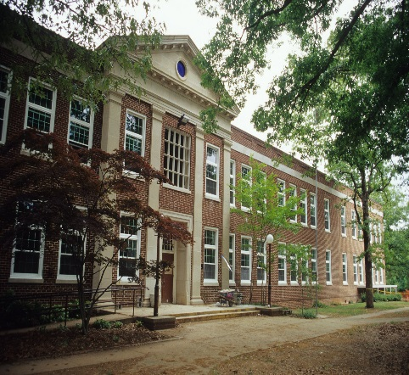

Field Trips

November 17
History Museum Native American Culture Fair/Museum of Natural Sciences Labs
$ TBD

March 9
Yorktown/Jamestown
$85/person

March 15
Camp Flintlock Colonial America field trip on campus
No $$ (PTA covers)

April 9
Motor Speedway in Charlotte
$$ TBD

Announcements
- -Tuesday Folders will have graded Wordly Wise, Figurative Language Test, and USA Studies Weekly assignment
- -Book Fair:
Ms. Bennett’s HR Tues., Oct. 3 @ 11:30am
Ms. Dalessio’s HR Wed., Oct. 4 @ 11:30am

Q1 Assigned Books Students Read At Home:
- -Gregor the Overlander
- -Escape From Mr. Lemoncello’s Library
- -Holes
- -The Cay/ Hatchet
- -Surviving the Applewhites
- -(Wait Till Helen Comes)
- -Ninth Ward
- -Night of the Twisters

EXPLORATION- POWER- SURVIVAL
http://claudiadalessioskare.weebly.com
Hello Families!
Friday’s Fun Center will be the making of totem poles, in celebration of the Native Americans of the northwest. If you are interested in volunteering, the first session is from 9:50-10:50 and the second, 10:50-11:50. The more adults present, the more smoothly the project will run. Thank you!
The students and I continue to discuss our three main abstract concepts (power, survival, and exploration). The bulk of our work has thus far been focused on power of words and exploration (as we are setting the stage for being caring citizens of our school as well as introducing the exploration of the New World). We will be making some comparisons this week with our at-home reading, our in-class novel study, historical events, and even Imagine Dragons’ “Radioactive” song lyrics. Graphic organizers will be started in class and completed for home work.
In ELA/SS the students and I have been reading The Last of the Really Great Whangdoodles and will spend time with vocabulary, figurative language, smart questioning, imagery, making connections, and song lyric analyses over the next few weeks. While we are no longer doing the “dreaded” nine part Whangdoodle Project as it has been done in the past, we will be completing aspects of it over the course of the quarter, in addition to an Exploration Project. Project expectations and rubrics will be forthcoming over the next week or two. Students will need to choose an explorer to research (1000-1599). We have glimpsed the Americas before colonization and will begin to look at the explorers and how they changed many aspects of North America.
The graded first figurative language test from The Last of the Really Great Whangdoodles will be in Tuesday Folders this week. We will continue reviewing terms. My Q1 Weebly has videos to help students review.
Thus far our grammar focus has been the basic building blocks of a sentence: the subject (nouns) and predicate (verbs). We will continue this thread and then students will take an online IXL test to demonstrate their comprehension.
In Geography students are working on beginning basic map reading skills. This week we will be covering the “A Map Grid.” In our USA Studies Weekly #4 students will be asked to answer questions about “How did it all begin?” If students have a “redo” on these assignments, I give them an opportunity to earn a 3 by redoing only the questions they get wrong. This helps them learn the material, improve their stamina, and realize the importance of slowing down and finding the right answer the first time around. There are very few inferring questions. Most of the questions are basic knowledge found within the passages.
We are in need of sticky masking tape, staples, and Elmer’s liquid glue.

Reading Journal Assignment for the Week!

This Week’s Home Work

Monday-
- Read 30 Pages
- Wordly Wise 4B; Test Friday, 9/22: Study!
- Artistic rendering for the power of words completed from class.
- 5 Sense Poem Rough Draft completed

Tuesday-Missing Work Print-Out Goes Home
- Read 30 Pages
- Wordly Wise 4C; Test Friday, 9/22: Study!
- Power of observation organizer completed from class.

Wednesday
- Read 30 Pages
- Wordly Wise 4 Wksht& 4D Test Friday, 9/22: Study!
- Complete power, exploration, & survival organizer from class.

Thursday- No School, Teacher Work day!
- Read 30 Pages
- Wordly Wise 4D; Test tomorrow: Study!

Friday
- Read 30 Pages
- USA Studies Weekly #4 (If not finished in class)

-Organizers completed from class work Monday-Wednesday

More Important News

Interested in Donating?
Here some books that will enliven our Social Studies units:
- To Sail on the Mayflower! A Trip That Took Entirely Too Long by Peter Cook $? (20 Copies)
- To Work on the Railroad! A Track You’d Rather Not Go Down by Ian Graham @ $? (20 Copies)
- To Explore With Sir Francis Drake! A Pirate You’d Rather Not Know by David Stewart @ $8.91/ea (20 Copies)
- To be an American Pioneer! A Wilderness You’d Rather Not Tame by Jacqueline Morley @ $9.95/ea (20 Copies)
- To be a Worker on the Statue of Liberty! A monument You’d Rather Not Build by John Malam @ $9.95/ea (20 Copies)
- To be at the Boston Tea Party! Wharf Water Tea You’d Rather Not Drink by Peter Cook @ $? (20 Copies)
- To be a Civil War Soldier! A War You’d Rather Not Fight by Thomas Ratliff @$9.95/ea (20 Copies)
- To Live in a Wild West Town! Dust You’d Rather Not Settle by Peter Hicks @$? (20 Copies)

Reading Rewards
Students that earn 25AR points by the end of September will be rewarded with a popcorn and movie party at lunch.

Volunteering
Are you interested in joining us on our field trips?
- Register for Wake County volunteering in the Media Center ASAP.
- 15 parents for Colonial Yorktown/Jamestown full day trip (5am-8:30pm)
- Remember, parent chaperones have to pay for their “ticket” to Williamsburg as well as their child’s.
http://claudiadalessioskare.weebly.com/volunteer.html
Friday Fun Centers in Social Studies interest you?
- Fridays from 9:50-10:50 (first session) and 10:50-11:50 (second session)
- Cook various foods at home that coincide to our units of study
- Come in and help with art projects that reflect our units of study
- Prepare art supplies at home for our projects

M-F Schedule (at the moment)
- 8:35-8:50 Morning Meeting
- 8:50-10:50 Justice League Math/Sci or Avenger ELA/SS
- 10:50-12:50 Avenger Math/Sci or Justice League ELA/SS
- 12:55-1:20 Lunch
- 1:20-1:50 Recess
- 1:55-2:45 Specials
- 2:45-3:00 Pack Up/Dismissal/Meditation/HW

