Quarter 2: October 31- November 4, 2016 Newsletter
5th Grade ELA/SS
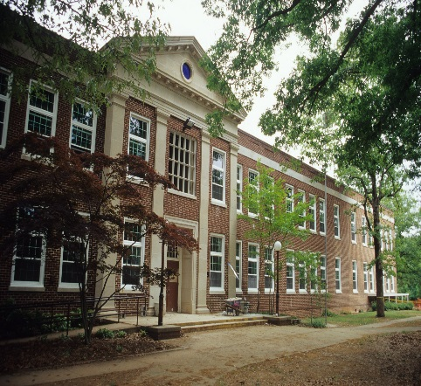

Field Trips

November 4
Camp Flintlock On-Campus
November 18
NC State Hunt Library
$2/student

March 3
Raleigh Capitol Building
$3.50/student

March 24
Colonial Williamsburg/Jamestown $108/person

Announcements
- Tuesday Folders will have graded Wordly Wise tests & missing work print-outs
- Quarter 2 begins 10/31
- Fall Portraits Friday, 11/4
Mr. Russell’s Time: 1:50-2:20
Ms. Dalessio’s Time: 2:20-2:40
- Poetry Contest Submission Deadline Nov. 15

Q2 Assigned Books Students Read At Home:
- Night of the Twisters
- Maniac Magee
- Sign of the Beaver
- The Ninth Ward
- Rules
- Inside Out and Back Again
- The Green Book

PATTERNS- PERSPECTIVE/PERCEPTION- TRADITION
http://claudiadalessioskare.weebly.com
Hello Families!
Welcome to Quarter 2! Students will turn in Quarter 1 notebooks and get out their new notebooks.
Monday is the last day to take AR tests for the popcorn and a movie October party. The party will occur Thursday or Friday of this week.
We will begin our new novel study, The Witch of Blackbird Pond by Elizabeth George Speare, this week. And students will be assigned their Quarter 2 novels to read.

With the beginning of our new novel, a discussion about perspective and the 1600s is also planned. An excerpt from the novel Feed will have students debating the consequences of technology, whereupon they will be asked to switch their perspectives and then discuss the fluidity of reversing roles and how that made them feel, once they owned a side. They will also be making comparisons to great orators such as MLK, Jr., Charlie Chaplin’s The Dictator, and one of the most horrible dictators, Hitler. Discussion about power of words and persuasion versus being a “good” person will follow.
Students, in partners, will use assigned Far Side comics to analyze and connect to literature and history of Quarter 1.
The grammar focus this week is subject and predicates, conjunctions, and commas.
Perspective through drawing and writing will come to play when students are asked to complete a design and do a short write-up about perspective and why it has power.
In Geography students will review a “Picturing the World.” And USA Studies Weekly # 8 “Early English Colonies” will be part of our Social Studies focus this week.

Reading Journal Assignment for the Week!

This Week’s Home Work

Monday:
- Read 30 Pages
- Wordly Wise 10B; Study!
- Figurative Language Test Thursday, 11/3 on The Witch of Blackbird Pond

Tuesday:
- Read 30 Pages
- Wordly Wise 10C; Study!
- Figurative Language Test Thursday, 11/3 on The Witch of Blackbird Pond
- Missing/Incomplete/Redo Work due by Friday, 11/4.

Wednesday:
- Read 30 Pages
- Wordly Wise Unit 10 worksheet; Study!
- Figurative Language Test tomorrow, 11/3 on The Witch of Blackbird Pond
- Missing/Incomplete/Redo Work due by Friday, 11/4.

Thursday:
- Read 30 Pages
- Wordly Wise 10D; Study!
- Missing/Incomplete/Redo Work due by tomorrow, 11/4.

Friday: Camp Flintlock!
- Read 30 Pages
- USA Studies Weekly #8

Not this week!

More Important News

Interested in Donating?
Here are some books that will enliven our Social Studies units:
- To Sail on the Mayflower! A Trip That Took Entirely Too Long by Peter Cook $? (25 Copies)
- To Work on the Railroad! A Track You’d Rather Not Go Down by Ian Graham @ $? (25 Copies)
- To Explore With Sir Francis Drake! A Pirate You’d Rather Not Know by David Stewart @ $8.91/ea (25 Copies)
- To be an American Pioneer! A Wilderness You’d Rather Not Tame by Jacqueline Morley @ $9.95/ea (25 Copies)
- To be a Worker on the Statue of Liberty! A monument You’d Rather Not Build by John Malam @ $9.95/ea (25 Copies)
- To be at the Boston Tea Party! Wharf Water Tea You’d Rather Not Drink by Peter Cook @ $? (15 Copies)
- To be a Civil War Soldier! A War You’d Rather Not Fight by Thomas Ratliff @$9.95/ea (25 Copies)
- To Live in a Wild West Town! Dust You’d Rather Not Settle by Peter Hicks @$? (25 Copies)

Reading Rewards
Students that earn 20 AR points by the end of October will be rewarded with a popcorn and movie party at lunch.

Volunteering
Are you interested in joining us on our field trips?
- Register for Wake County volunteering in the Media Center ASAP.
- 15 parents for Colonial Williamsburg/Jamestown full day trip (5am-8:30pm)
- Remember, parent chaperones have to pay for their “ticket” to Williamsburg as well as their child’s.
http://claudiadalessioskare.weebly.com/volunteer.html
Friday Fun Centers in Social Studies interest you?
- Fridays from 9:40-10:28 (first session) and 10:30-11:18 (second session)
- Cook various foods at home that coincide to our units of study
- Come in and help with art projects that reflect our units of study
- Prepare art supplies at home for our projects

M, W, F Schedule
- 8:35-8:50 Morning Meeting
- 8:50-10:28 Rebel Alliance Math/Sci or Rogue Squadron ELA/SS
- 10:30-11:30 Rogue Squadron Math/Sci or Rebel Alliance ELA/SS
- 11:32-12:02 Lunch
- 12:02- 12:32 Recess
- 12:35- 1:25 Specials
- 1:32-2:20 Rogue Squadron Math/Sci or Rebel Alliance ELA/SS continued
- 2:20-2:50 Genius Hour/Reteach/Enrich (Wednesdays AIG ELA meets from 2:05-2:50)
- 2:50-3:00 Pack Up/Dismissal

T/TH Schedule
- 8:35-8:50 Morning Meeting
- 8:50-10:28 Rebel Alliance Math/Sci or Rogue Squadron ELA/SS
- 10:30-11:30 Rogue Squadron Math/Sci or Rebel Alliance ELA/SS
- 11:32-12:02 Lunch
- 12:02- 12:32 Recess
- 12:35- 1:25 Specials
- 1:32-2:30 Rogue Squadron Math/Sci or Rebel Alliance ELA/SS continued
- 2:30-2:50 Rebel Alliance Math/Sci or Rogue Squadron ELA/SS
- 2:50-3:00 Pack Up/Dismissal

