Quarter 1: September 5-8, 2017 Newsletter
5th Grade ELA/SS
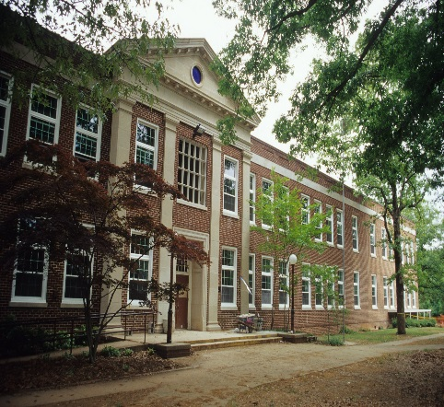

Field Trips

November 17
History Museum Native American Culture Fair/Museum of Natural Sciences Labs
$ TBD

March 9
Yorktown/Jamestown
$75/person

March 15
Camp Flintlock Colonial America field trip on campus
No $$ (PTA covers)

April 9
(Tentative)Motor Speedway in Charlotte
$$ TBD

Announcements
- Tuesday Folders will have graded Wordly Wise and Figurative Language Tests
- Bug Fest Sept 16th

Q1 Assigned Books Students Read At Home:
- -Gregor the Overlander
- -Escape From Mr. Lemoncello’s Library
- -Holes
- -The Cay/ Hatchet
- -Surviving the Applewhites
- -(Wait Till Helen Comes)
- -Ninth Ward
- -Night of the Twisters

EXPLORATION- POWER- SURVIVAL
http://claudiadalessioskare.weebly.com
Hello Families!
The students and I have been discussing our three main abstract concepts (power, survival, and exploration) for the past two weeks. The bulk of our work has thus far been focused on power of words and exploration (as we are setting the stage for being caring citizens of our school as well as introducing the exploration of the New World).
In ELA/SS the students and I have been reading The Last of the Really Great Whangdoodles and will spend time with vocabulary, figurative language, smart questioning, imagery, making connections, and song lyric analyses over the next few weeks. While we are no longer doing the “dreaded” nine part Whangdoodle Project as it has been done in the past, we will be completing aspects of it over the course of the quarter, in addition to an Exploration Project. Project expectations and rubrics will be forthcoming over the next week or two.
Power partner work will begin this week. Each partnership will determine the types of power their topic has and create a chain of impact. For example, friendship, forgiveness, laws, technology, knowledge, history…how these topics have power and why.
Your children have taken their first figurative language assessment last Thursday, which will give me a baseline of their ability in this domain. We can work from there to improve and refine skills. It will not impact their grade.
Thus far our grammar focus has been the basic building blocks of a sentence: the subject (nouns) and predicate (verbs).
In Geography students are working on beginning basic map reading skills. This week we will be covering the “Globe Lines.” In our USA Studies Weekly #2 students will be asked to answer questions about “U.S. States and Regions.”
We are in need of sticky masking tape, staples, and Elmer’s liquid glue.

Reading Journal Assignment for the Week!

This Week’s Home Work

Monday- Labor Day!
- Read 30 Pages

Tuesday
- Read 30 Pages
- Wordly Wise 2B & 2C; Study!
- Q1 Reading Journal Part 1 question finished from class.

Wednesday
- Read 30 Pages
- Wordly Wise Unit 2 worksheet; Study!
- Q1 Reading Journal Part 2 completed

Thursday
- Read 30 Pages
- Wordly Wise 2D; Study!
- I am Poem (if not completed in class)

Friday
- Read 30 Pages
- USA Studies Weekly #2 (If not finished in class)

Reading Journal Q1 #1 Part I Tuesday, September 5th, 2017
- In the novel The Last of the Really Great Whangdoodles by Julie Andrews Edwards, Professor Savant states, “The whole world could pass them by and most people wouldn’t notice (11).” And later on he tells the children, “There aren’t many people in this world who really know how to look….It’s such a pity, for there is texture to everything we see, and everything we do and hear…I want you to start noticing things (47-48).” Being a good observer is a powerful tool and is key to our survival and exploration. Describe a room inside your house without stating which room it is and let us see if we can surmise the room based on your descriptive details and use of figurative language. You should have ¾ to one full page of writing and you may type it, if that’s easier.
Reading Journal Q1 #1 Part II Wednesday, September 6th, 2017
- Using the novel you have been assigned to read at home (Gregor, Lemoncello’s Library, Holes, Night of the Twisters, Ninth Ward…), compare and contrast the power of one of the characters versus a character from The Last of the Really Great Whangdoodles. Explain your connections using quotes from the assigned novel to support your ideas and detailed paraphrasing from The Last of the Really Great Whangdoodles. (15 sentences minimum. Choose at least 4 ideas to connect for each character. Don’t forget your topic and concluding sentences).

More Important News

Interested in Donating?
Here some books that will enliven our Social Studies units:
- To Sail on the Mayflower! A Trip That Took Entirely Too Long by Peter Cook $? (20 Copies)
- To Work on the Railroad! A Track You’d Rather Not Go Down by Ian Graham @ $? (20 Copies)
- To Explore With Sir Francis Drake! A Pirate You’d Rather Not Know by David Stewart @ $8.91/ea (20 Copies)
- To be an American Pioneer! A Wilderness You’d Rather Not Tame by Jacqueline Morley @ $9.95/ea (20 Copies)
- To be a Worker on the Statue of Liberty! A monument You’d Rather Not Build by John Malam @ $9.95/ea (20 Copies)
- To be at the Boston Tea Party! Wharf Water Tea You’d Rather Not Drink by Peter Cook @ $? (20 Copies)
- To be a Civil War Soldier! A War You’d Rather Not Fight by Thomas Ratliff @$9.95/ea (20 Copies)
- To Live in a Wild West Town! Dust You’d Rather Not Settle by Peter Hicks @$? (20 Copies)

Reading Rewards
Students that earn 25AR points by the end of September will be rewarded with a popcorn and movie party at lunch.

Volunteering
Are you interested in joining us on our field trips?
- Register for Wake County volunteering in the Media Center ASAP.
- 15 parents for Colonial Yorktown/Jamestown full day trip (5am-8:30pm)
- Remember, parent chaperones have to pay for their “ticket” to Williamsburg as well as their child’s.
http://claudiadalessioskare.weebly.com/volunteer.html
Friday Fun Centers in Social Studies interest you?
- Fridays from 9:50-10:50 (first session) and 10:50-11:50 (second session)
- Cook various foods at home that coincide to our units of study
- Come in and help with art projects that reflect our units of study
- Prepare art supplies at home for our projects

M-F Schedule (at the moment)
- 8:35-8:50 Morning Meeting
- 8:50-10:50 Justice League Math/Sci or Avenger ELA/SS
- 10:50-12:50 Avenger Math/Sci or Justice League ELA/SS
- 12:55-1:20 Lunch
- 1:20-1:50 Recess
- 1:55-2:45 Specials
- 2:45-3:00 Pack Up/Dismissal/Meditation/HW

