Quarter 4: May 23- May 27 Newsletter
5th Grade ELA/SS
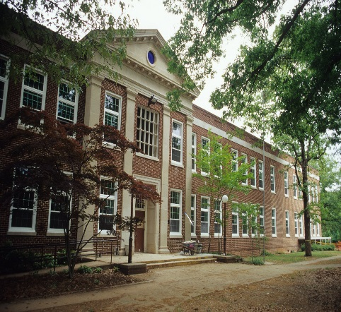

Announcements
- Q4 Missing work print-outs sent home in Tuesday Folders
- Field trip $$ PAST due
- Social Justice Project Presentation Wed., 5/25 8:45-10:45am in the cafeteria
- ELA EOG Thurs., 5/26
- Math EOG Fri., 5/27
- Memorial Day Mon., 5/30
- Science EOG Wed., 6/1
- Fly Up Day Fri., 6/3
- 1800s Newspaper Project Due 6/3
- Graduation Tues., 6/7
- Kickball Game Thurs., 6/9
- Last Day Thurs., 6/9
Q4 Assigned Books Students Read at Home:
- Night of the Twisters
- Across the Wide & Lonesome Prairie
- Navigating Early
- I Survived The Battle of Gettysburg
- The Ninth Ward
- Emma & the Civil Warrior

If any of the above books have already been read then the following can supplement:
- Tuck Everlasting
- The Cay

PATTERNS- MIGRATION- EXTINCTION
http://claudiadalessioskare.weebly.com
Hello Families!
Students need to be reading their assigned Q4 novel.
Q4 Social Studies Standards’ focus: Development of Government, Economics, Globalization, Slavery, Westward Movement/Manifest Destiny, War of 1812, Spanish-American War, The Alamo, Native Americans, Civil War, Industrialization, Gold Rush, Political Cartoons, Geography (learning the 50 States & Capitals).
Q4 ELA Standards’ focus: Roots/Prefixes, Figurative Language, Characterization, Point of View, Mood/Tone, Author’s Purpose, Making Inferences, Drawing Conclusions, Quoting Accurately from a Text, Theme, Context Clues, Puns, Idioms, Proverbs, Plays, Tall Tales, Editorial Writing (Opinion Essay), Feature Story (Informational Essay), grammar & punctuation
This is a great time for students to utilize Study Island nightly, especially if they are not performing on grade level in either Math, Reading, or Science. If students do not pass the Reading or Math EOG they will most likely have to take a remedial class in that subject instead of a fun elective, in 6th grade.
Completing the Social Justice Projects (with editing and discussion about presentational skills), working on the 1800s Newspaper Project, USA Studies Weekly #s 26-28, and reading Homer P. Figg are the focus for the week. Also, students will be introduced to the Editorial and Feature Story pieces of their Newspaper Project.
WANTED: glue sticks, and colored pencils, & colored drawing markers.

Reading Journal Assignment: Not this week! Study Island, Newspaper Project, and catch up on missing/redo assignments!

This Week’s Home Work

HOMEWORK:

Monday:
- Read 20-30 Pages in assigned novel.
- Newspaper Project: 2 Political cartoons, 4 horoscopes, 2 comic strips, 5 advertisements, & Tall Tale should have been finished last week.
- EOG Review: Study Island
- Social Justice Project presentation Wed., 5/25
- USA Studies Weekly #26, if not finished in class.
- Late, re-do, missing work!

Tuesday: Q4 Missing Work Print Outs
- Read 20-30 Pages in assigned novel.
- Newspaper Project: 2 Political cartoons, 4 horoscopes, 2 comic strips, 5 advertisements, & Tall Tale should have been finished last week.
- EOG Review: Study Island
- Social Justice Project presentation TOMORROW!!!!
- USA Studies Weekly #27, if not finished in class.
- Late, re-do, missing work!

Wednesday: Social Justice Project Presentations!
- Read 20-30 Pages in assigned novel.
- RELAX, GET A GOOD NIGHT’S REST, EAT A HEALTHY BREAKFAST
- USA Studies Weekly #28, if not finished in class.

Thursday: ELA EOG TODAY!
- Read 20-30 Pages in assigned novel.
- RELAX, GET A GOOD NIGHT’S REST, EAT A HEALTHY BREAKFAST

Friday: MATH EOG TODAY!
- Newspaper Project: 2 Political cartoons, 4 horoscopes, 2 comic strips, 5 advertisements, & Tall Tale should have been finished last week. CATCH UP!
- Late, re-do, missing work!
Monday: Memorial Day (NO SCHOOL)

1800s Q4 Newspaper Project Grading Check Sheet
Tall Tale (Create Your Own Hero/Legend) 1 Page
Cover the weather (mood) of the 1800s map & blurb included
Feature Story (5 Paragraph Essay) on an 1800s Topic
4 Horoscopes (faux predictive statements) addressing any of the Q4 novels read
Editorial (5 Paragraph Opinion Essay) about slavery, child labor, industrialization, women’s rights, Indian Removal Act…
5 Advertisements based on inventions/products of the 1800s
2 student created Comic Strips that illustrate events of the 1800s
2 student created Political Cartoons that address issues from the 1800s (can be a topic from the Feature Story or Editorial)
Title Page (create a clever newspaper title/name) with index and 1800s date (preferably something late 1890s)
Visually Appealing and neat
Extra Credit: Extra articles, ads, pictures, crossword puzzles, inventions, songs…of the time period

Book Donation Ideas:
- Navigating Early by Clare Vanderpool (8 copies)
- The Dreadful, Smelly Colonies: The Disgusting Details About Life in Colonial America by Elizabeth Raum (16 copies)
- Her Stories: African American Folktales, Fairy Tales, and True Tales by Virginia Hamilton (20 copies)
- Breaking Stalin’s Nose by Eugene Yelchin (20 copies)
Thanks to all families that have already donated! Your donations make a huge difference!

Reading Rewards
Students that earn 20 AR/Book Adventure points by the end of May will be rewarded with a popcorn and movie party at lunch.

M-F Schedule
- 8:35-10:35 Math/Sci or ELA/SS
- 10:35-11:40 Math/Sci or ELA/SS Group 2
- 11:45-12:40 Specials
- 12:40-1:10- Lunch
- 1:10- 2:20: Math/Sci or ELA/SS
Group 2 Continued
- 2:20-2:50 Recess
- 2:50-3:00 Pack Up/Dismissal

