Quarter 4: May 30- June 3 Newsletter
5th Grade ELA/SS
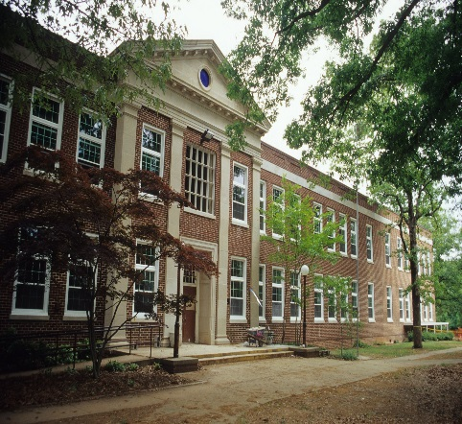

Announcements
- Last Q4 Missing work print-outs sent home in Tuesday Folders
- Field trip $$ PAST due
- Science EOG Wed., 6/1 (8:45-?)
- All Late/Redo Work due Thurs., 6/2
- Parent Mtg. for Human Growth & Development Lessons Thurs., 6/2 5:30pm
- Fly Up Day Fri., 6/3 (1:30-2:30pm)
- 1800s Newspaper Project Due Fri., 6/3
- Teaching Human Growth & Development Mon., 6/6
- Graduation Practice Mon., 6/6 (1:20-2:20pm)
- Graduation Tues., 6/7 (9-11am) & Dance Party (1-2:40pm)
- Kickball Game Thurs., 6/9
(9-10am)
- Last Day Thurs., 6/9 & Report Cards sent home
Q4 Assigned Books Students Read at Home:
- Night of the Twisters
- Across the Wide & Lonesome Prairie
- Navigating Early
- I Survived The Battle of Gettysburg
- The Ninth Ward
- Emma & the Civil Warrior

PATTERNS- MIGRATION- EXTINCTION
http://claudiadalessioskare.weebly.com
Hello Families!
Students need to be reading their assigned Q4 novel.
Q4 Social Studies Standards’ focus: Development of Government, Economics, Globalization, Slavery, Westward Movement/Manifest Destiny, War of 1812, Spanish-American War, The Alamo, Native Americans, Civil War, Industrialization, Gold Rush, Political Cartoons, Geography (learning the 50 States & Capitals).
Q4 ELA Standards’ focus: Roots/Prefixes, Figurative Language, Characterization, Point of View, Mood/Tone, Author’s Purpose, Making Inferences, Drawing Conclusions, Quoting Accurately from a Text, Theme, Context Clues, Puns, Idioms, Proverbs, Plays, Tall Tales, Editorial Writing (Opinion Essay), Feature Story (Informational Essay), grammar & punctuation
Working on the 1800s Newspaper Project, The Hunley, USA Yesterday “Departure of the 7th Regiment,” The Orphan Train, and reading Homer P. Figg are the focus for the week. Also, students will be writing their Editorial and Feature Story pieces for their Newspaper Project and the weather piece will be addressed regarding mood/tone.
WANTED: glue sticks, and colored pencils, & colored drawing markers.

Reading Journal Assignment: Not this week! Study Island, Newspaper Project, and catch up on missing/redo assignments!

This Week’s Home Work

HOMEWORK:

Monday: Memorial Day Holiday!
- Read 20-30 Pages in assigned novel.
- Newspaper Project: 2 Political cartoons, 4 horoscopes, 2 comic strips, 5 advertisements, & Tall Tale should have been finished two weeks ago.
- Editorial (5 paragraph Opinion Essay) due Thursday
- Feature Story (5 paragraph Informational Essay) due Thursday
- Late, re-do work due Thursday, 6/2

Tuesday: Q4 Missing Work Print Outs
- Read 20-30 Pages in assigned novel.
- Newspaper Project: 2 Political cartoons, 4 horoscopes, 2 comic strips, 5 advertisements, & Tall Tale should have been finished two weeks ago.
- Editorial (5 paragraph Opinion Essay) due Thursday
- Feature Story (5 paragraph Informational Essay) due Thursday
- Late, re-do work due Thursday, 6/2
- Get a good night’s rest

Wednesday: Science EOG!
- Read 20-30 Pages in assigned novel.
- Newspaper Project: 2 Political cartoons, 4 horoscopes, 2 comic strips, 5 advertisements, & Tall Tale should have been finished two weeks ago.
- Editorial (5 paragraph Opinion Essay) due Thursday
- Feature Story (5 paragraph Informational Essay) due Thursday
- Late, re-do work due tomorrow, 6/2.

Thursday: Last day to turn in late/redo work!
- Read 20-30 Pages in assigned novel.
- Newspaper Project due tomorrow!

Friday: Newspaper Project Due!
- Newspaper Project due!
- Fly Up Day 1:30-2:30pm

1800s Q4 Newspaper Project Grading Check Sheet
Tall Tale (Create Your Own Hero/Legend) 1 Page
Cover the weather (mood) of the 1800s map & blurb included
Feature Story (5 Paragraph Essay) on an 1800s Topic
4 Horoscopes (faux predictive statements) addressing any of the Q4 novels read
Editorial (5 Paragraph Opinion Essay) about slavery, child labor, industrialization, women’s rights, Indian Removal Act…
5 Advertisements based on inventions/products of the 1800s
2 student created Comic Strips that illustrate events of the 1800s
2 student created Political Cartoons that address issues from the 1800s (can be a topic from the Feature Story or Editorial or neither)
Title Page (create a clever newspaper title/name) with index and 1800s date (preferably something late 1890s)
Visually Appealing and neat
Extra Credit: Extra articles, ads, pictures, crossword puzzles, inventions, songs…of the time period

Thanks to all families that have already donated! Your donations make a huge difference!

